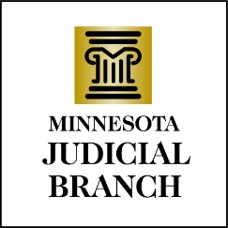

Judicial Council Agenda
September 14, 2023
9:00 a.m.
Room 230, MN Judicial Center and via Zoom

- Approval of Draft August 17, 2023, Meeting Minutes

- Governance Follow Up

- Discussion Item: oneCourtMN Hearings Initiative (OHI) Update

- Discussion Item: Performance Measures Report

- Discussion Item: EP312: Advancement of Vulnerable Care Data Collection

- Discussion Item: Statewide Court Records Audit

- Discussion Item: HR/EOD Committee Update on Law Clerk Hiring

- Discussion Item: FY2022/23 MJB Financial Closing Report

- Discussion/Decision Item: Draft Payables List Out for Public Comment

- Discussion Item: Other Business

- Adjourn

