MMC changes to the Income and Expense Tab
We have made changes to the Income and Expense tab of MyMNConservator. These changes will improve the performance of the application. When you view your transactions, you can choose to see 10, 25 or 50 transactions on a page. If you choose 10 the system should preform faster than if you choose 50. Click on the number you want choose. The default is 10 transactions.
When you enter transactions, they will post in date order with the most current first. If you don’t see the transaction you entered, make sure to check other pages. You can select the page you want to view from the numbers, 1,2,3 etc or you can click next, last, first or previous. The application will default to page one after each addition, edit or deletion of a transaction. Make sure to click on the correct account on the left hand side to see the transactions entered in that account.
If you entered some transactions directly within the application and some transactions by .csv upload the transactions may show on different pages.
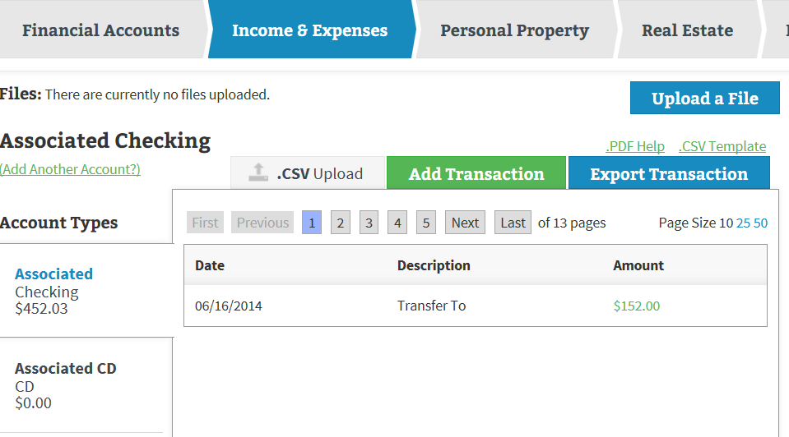
To check your transactions here are some options:
- On the Income & Expense tab, Export transactions
- On the Review & Submit tab, Click Print for a print preview of all transactions by category
- On the Review & Submit tab, Scroll down the page until you see Income & Expense Overview
Click the detailed overview and you can sort your transactions.

