CERTIFICATE OF ATTENDANCE

This is to certify that the following person attended this CJI training event:

Name:

CFSR OVERVIEW

7/15/08
8:00 a.m.-9:00 a.m.
Interactive Television (ITV) Presentation

Approved for 1.0 GAL, CJE, and CME continuing education credits.
Application has been made for 1.0 standard CLE credits for attorneys.
Social workers may contact the Board of Social Work to apply for continuing education credits.

Sponsored by:
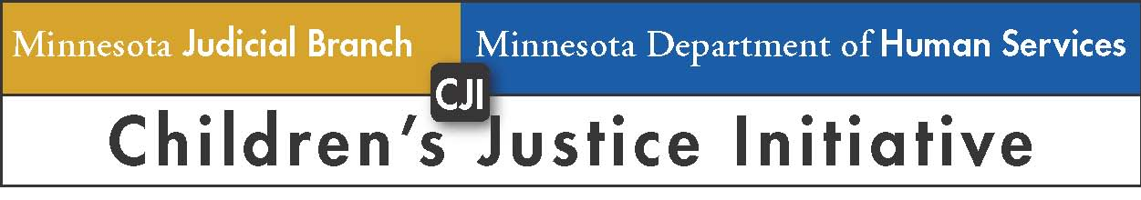

Children’s Justice Initiative
State Court Administrator’s Office
25 Rev. Dr. Martin Luther King Jr. Blvd., Suite 105
St. Paul, MN 55155
Phone: 651-297-1114

