Local Ordinance and Administrative Rule Look up Tool
Copyright © 2014 by the State of Minnesota Judicial Branch. All Rights Reserved.
These instructions are intended for use by criminal justice agencies to aid them in searching for administrative rules and local ordinances.
Background
The MNCIS Offense Table has been updated to include offense codes for Local Ordinances and Administrative Rules violations. This tool has been created to provide criminal justice agencies access to the information in one centralized location. Criminal justice agencies can use the information to populate their offense code tables and aid them in the submission of eCitations. Agencies who are submitting eCitations using the 3.5 schema will be required to submit administrative rules and local ordinances using an individually-assigned reference identification number.
Note: Agencies using the 3.4 eCitation schema will continue to map the offense to the generic codes.
Accessing the Tool
Users can access this tool from the Minnesota Judicial Branch website via the following link: Administrative Rules and Ordinances MNCIS Report. Users must enter specific information in the search fields to generate results. The following steps explain each field and suggest best practices when searching for local ordinances and administrative rules.
- Enter a Begin Date.
  - The begin date is the historical date to which you would like your query to return information. The tool looks at either the date the rule/ordinance was created or the date the ordinance/rule was changed.
  - For example, if the begin date is 7/1/1995 the results will show all local ordinances and administrative rules starting this date forward.
Note:
The Court uses a default date of 1/01/1900 to symbolize that the offense was part of the original creation of the MNCIS Offense code table. It is not recommended that you use the default begin date of 01/01/1900 as this will return all data and cause a long processing time to get results.
- Enter an End Date.
- This is the end date parameter for which you want to retrieve results in the query.
- For example, if the end date is 6/1/2014 the tool returns the ordinances/rules up to this date and any rules/ordinances added after this date are excluded from the results.
- Select the Offense Type.
  - Choose Select All, Administrative Rule or Local Ordinance.
  - It is not recommended that users choose Select All and enter the begin date of 01/01/1900 with today’s current end date. This will return voluminous information that may take some time to generate. It is best to use limited time periods and look up administrative rules and local ordinances separately, rather than generating them into one report.
- Enter the Owner/Jurisdiction filter.
  - The Owner/Jurisdiction field allows the user to specify for which organization of government the administrative rule or local ordinance is applicable. This data field defaults with NULL checked. If left checked, the tool returns statewide data based upon the date parameters and offense type selected.
  - For example, if a user needs ordinance information for the City of Red Wing, they may type “Red Wing” and select View Report. The user could also simply enter the word Red and select View Report.
  - If “Red” is typed, the report returns information for Red Lake Falls, Red Wing, Sacred Heart and Redwood Falls. The keyword search looks for all possible matches that contain the keyword.
Note:
If looking for administrative rules, users may type “State MN” in the Owner/Jurisdiction field.
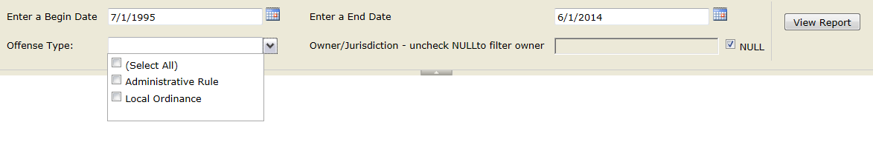

Sample of Administrative Rule Search Results:
After clicking View Report and once the results display users may page through the information, adjust the view size, do a keyword search, refresh the data, or print results. Users may also export search results in an alternative format, for example XML, CSV, PDF, MHTML, Excel, TIFF, or Word.
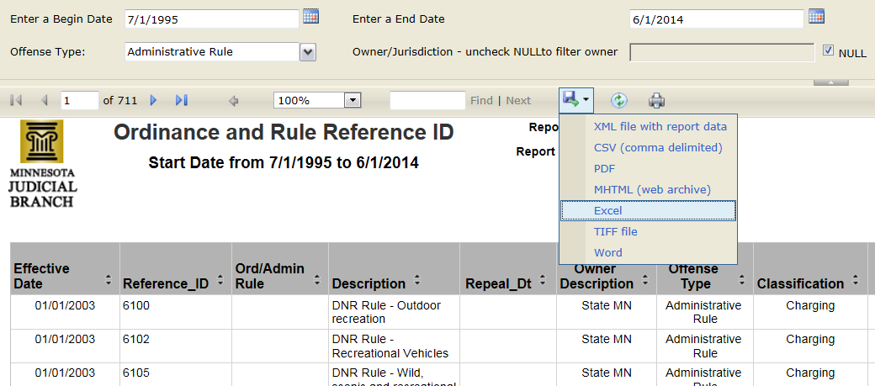
With your cursor, hover over the icons and the name/function will display.

Sample of Ordinance Data Results:
Information within the generated report will be categorized with the following columns:
- Effective Date
- Reference ID
- Ord/Admin Rule
- Description
- Repeal Date
- Owner Description
- Offense Type
- Classification
- Default Degree
- Misdem (Misdemeanor)
- Petty MSD (Petty Misdemeanor)
- Cert to DPS Required
- DNR Required
- Mandatory Court Appearance
- Date Created
- Date Changed
This information can be searched and filtered when exported in one of the available formats.

Trouble Shooting:
If you have questions and/or comments about this tool, please send them to: State.Standard.Citation@courts.state.mn.us

