Summary Information on
Juvenile Delinquency Petitions in
Minnesota Courts

Calendar Year 2003

Submitted
Pursuant to M.S. § 260B.173

March 2005

Prepared by
Research and Evaluation
Court Services Division
State Court Administrator’s Office
Minnesota Supreme Court

Juvenile Delinquency Petitions in Minnesota Courts
Calendar Year 2003

Highlights

- In calendar year 2003 over 23,000 delinquency petitions were filed in Minnesota courts. Delinquency petitions represent 36% of all petitions filed in juvenile court. Slightly over half (54%) of the delinquency petitions in 2003 were for misdemeanor offenses, 36% were for felonies and 10% were for gross misdemeanors. This distribution is consistent with patterns observed in previous years.

- The Fourth Judicial District had the largest number of petitions (4,436), followed by the First District (4,107) and the Tenth District (3,022). These three districts account for one-half of the delinquency petitions filed statewide.

- For delinquency petitions filed in 2003, the average age of the juveniles involved was fifteen. More than three-quarters (78%) of the juveniles were fourteen years old or older.

- Overall, 73% of all delinquency petitions filed in 2003 involved males; the percentage was higher (83%) for felony delinquencies.

- Most felony delinquency petitions involved property offenses (56% in 2003). The most common alleged felony offenses were Theft and Burglary, which together account for nearly one-half of the felony filings.

- In 77% of the juvenile delinquency petitions disposed in 2003 there was either an admission of guilt or a finding of guilt or delinquency.

- The most common dispositional conditions ordered for delinquency petitions in 2003 were financial sanctions (including fines, restitution and community work service), supervision/probation and evaluation, treatment or counseling. Letters of apology to victims were also very common.

Summary Information on
Juvenile Delinquency Petitions in Minnesota Courts
Calendar Year 2003

Juvenile courts in Minnesota hear a large number and wide variety of cases each year. In calendar year 2003, 65,000 juvenile petitions were filed. Almost half of the petitions involved status and juvenile petty offenses. Status offenses are those acts that are unlawful for a juvenile but are not crimes if committed by an adult. Juvenile courts also hear cases involving Children in Need of Protection or Services (CHIPS). CHIPS cases address issues such as dependency/neglect, truancy, runaways and the termination of parental rights.

Over one-third of juvenile court filings in 2003 involved delinquency petitions. A delinquency petition is filed when a child aged ten through seventeen is alleged to have committed an act that would be a crime if committed by an adult. Pursuant to M.S. § 260B.173, this report focuses on the delinquency petitions filed or disposed in Minnesota in calendar year 2003 and includes information on the types of offenses involved, the geographic and demographic distribution of cases and the specific dispositional outcomes ordered by the court. Aggregated information by judicial district and a copy of MS. § 260B.173 are included in the Appendices.

Petitions Filed in 2003

Delinquency Petition Type

In calendar year 2003, there were 23,079 delinquency petitions filed in Minnesota courts. Delinquency petitions are grouped into three categories, based on the level of the most serious alleged act: felonies, gross misdemeanors, and misdemeanors. Statewide, slightly over half (54%) of delinquency petitions filed in 2003 were for misdemeanor offenses, 36% for felonies and 10% for gross misdemeanors. This distribution is consistent with patterns observed in previous years.
Juvenile Delinquency Filings in 2003 – Type of Petition by Judicial District

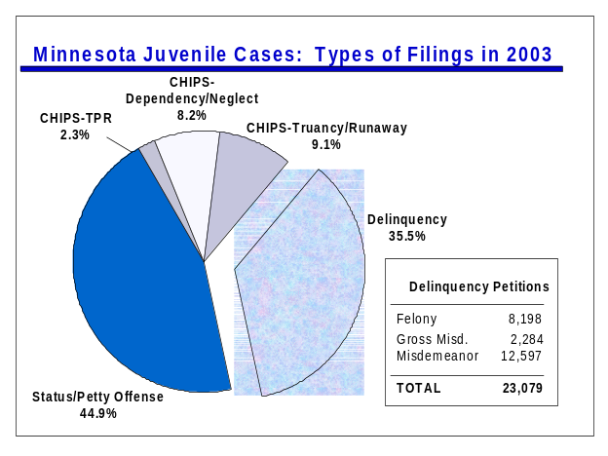
Jud. Dist. | Total # Del. Petitions | Type of Del. Petition
Jud. Dist. | Total # Del. Petitions | Felony | Gross Misd. | Misd.
1 | 4,107 | 923 | 322 | 2,862
2 | 2,489 | 868 | 340 | 1,281
3 | 1,655 | 758 | 148 | 749
4 | 4,436 | 1,656 | 481 | 2,299
5 | 1,113 | 449 | 114 | 550
6 | 1,222 | 437 | 87 | 698
7 | 1,925 | 765 | 173 | 987
8 | 751 | 305 | 77 | 369
9 | 2,359 | 812 | 172 | 1,375
10 | 3,022 | 1,225 | 370 | 1,427
Total | 23,079 | 8,198 | 2,284 | 12,597

Geographic Distribution

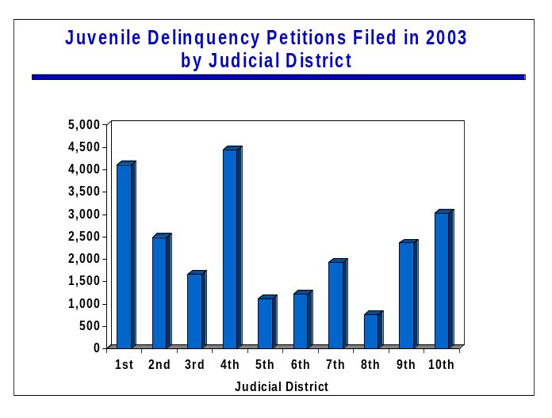The First, Fourth and Tenth Judicial Districts accounted for one-half (50%) of the delinquency petitions filed in the state. The Fourth District (Hennepin County) had the largest number of felony and gross misdemeanor petitions. The distribution of filings by offense level varies by district. For example, the First District had a higher proportion of petitions for misdemeanor offenses (70%) compared to the statewide average (54%).

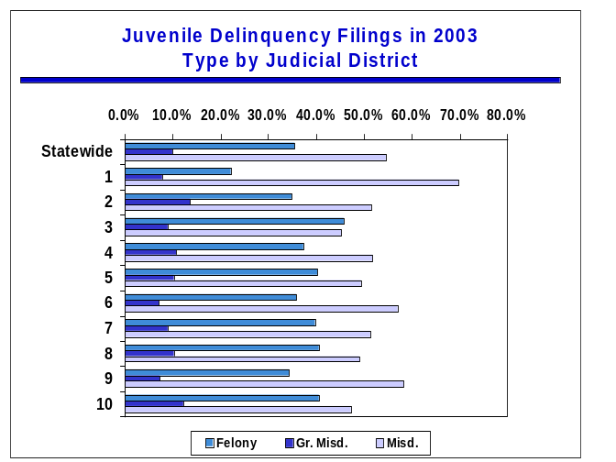
AGE, GENDER AND RACE

In 2003, the average age of juveniles involved in delinquency petitions was 15 (at the time of the offense). Juveniles fourteen years of age and older were involved in more than three-quarters (81%) of the cases.

Seventy-three percent of all delinquency petitions filed in 2003 involved males and 23% involved females. In 4% of the cases, this information was not available. The percentage of juveniles who are male is highest for felony level petitions (83% as compared to 71% for gross misdemeanors and 68% for misdemeanors).
Felony Delinquency Filings – 2001
Most Severe Offense
Offense | Number | Percent
Theft/Stolen Property | 2,684 | 28.6
Burglary | 1,864 | 19.8
Assault | 1,310 | 13.9
Property Damage | 773 | 8.2
Drugs | 670 | 7.1
Sex Offenses | 552 | 5.9
Weapons | 366 | 3.9
Robbery | 331 | 3.5
Homicide | 20 | 0.2
Other | 663 | 7.0
Unknown | 160 | 1.7
Total | 9,393 | 100%

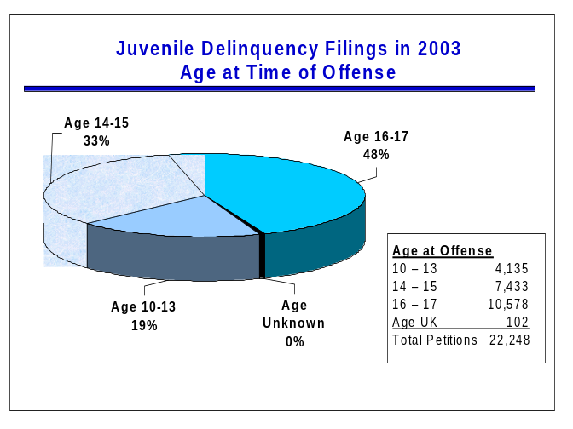
Data on petitions filed in Scott County in 2003 by age and gender are not available. As explained at the end of this report, the only juvenile data available for Scott County are the number of petitions filed by type of petition and by race.

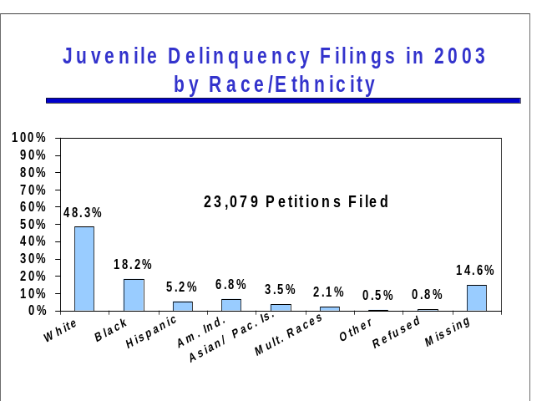The courts began collecting self-reported race information on all juvenile cases in July 2001. In addition to self-reported race information which is collected when a juvenile makes an appearance in court, the Juvenile Rules require race information to be recorded on the charging document. For delinquency cases the charging document is the petition. This “observed” race data is included in the percentages when self-reported race is missing.

In 2003, the largest percentage of the 23,079 petitions filed involved white juveniles (48.3%). Black juveniles represent 18.2% of the petitions filed followed by American Indians (6.8%), Hispanics (5.2%) and Asian/Pacific Islanders (3.5%). In less than one percent of the cases there was a refusal to provide race data. For 14.6% of the cases the race of the juvenile is missing.

Offense Type

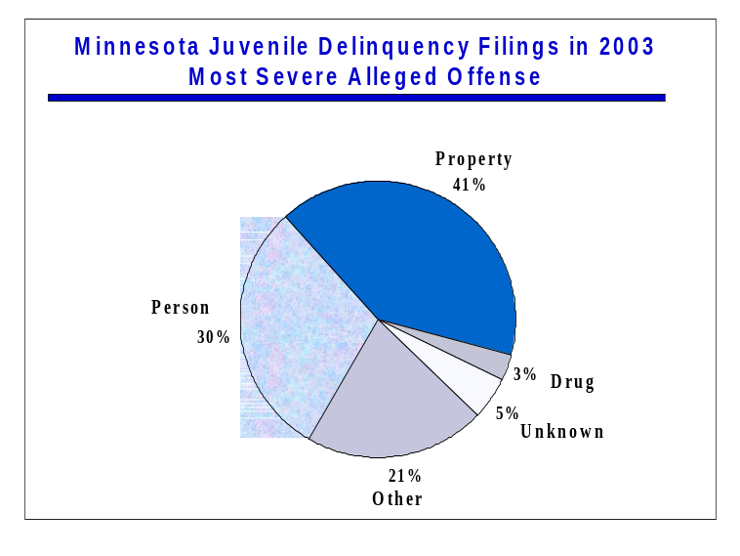The largest proportion of delinquency petitions filed involve property offenses. In 2003, 41% involved a property offense, 30% involved a person offense, 3% involved a drug offense, and 21% involved other types of offenses. The “other offense” category consists primarily of non-felony offenses (88%); the most common being disorderly conduct, obstruction of the legal process, and juvenile alcohol offenses.

When examined by petition type, a higher proportion of misdemeanors involved person offenses (35%) as compared to felonies (26%) and gross misdemeanors (20%). This is due to the large number of misdemeanor level assaults.

The most common alleged felony offenses were Theft and Burglary, which together account for almost one-half (46%) of all the felony filings. Person offenses were less common than property offenses. Felony assaults totaled less than one-half of alleged felony theft offenses. Homicide was the most severe offense at filing in 27 of the nearly 8,200 felony delinquency petitions filed in 2003. Data on petitions filed in Scott and Carver counties by type of offense are not available.
Felony Delinquency Filings in 2003
Most Severe Alleged Offense
Offense | Number | Percent
Theft/Stolen Property | 2,081 | 25.4%
Burglary | 1,668 | 20.3%
Assault | 1,036 | 12.6%
Property Damage | 869 | 10.6%
Drugs | 574 | 7.0%
Sex Offenses | 471 | 5.7%
Weapons | 306 | 3.7%
Robbery | 275 | 3.4%
Homicide | 27 | 0.3%
Other Offense | 632 | 7.7%
Unknown | 259 | 3.2%
Total | 8,198 | 100.0%

Cases Disposed in 2003

There were 19,036 delinquency petitions with an initial disposition in calendar year 2003 (6,170 felonies, 2,419 gross misdemeanors, and 10,447 misdemeanors). These figures do not, however, include any data for Scott County. As explained at the end of this report, dispositional data for Scott County juvenile cases are not available for all of 2003 and not available for Carver County since February 2003. Therefore, these data are not included in dispositional totals for the First Judicial District. The disposition data discussed in this section also do not include cases for which the only closing activity or disposition was a change of venue to another county (juvenile cases are frequently transferred between counties if the juvenile resides in another county).

Type of Initial Disposition

In 77% of the juvenile delinquency petitions disposed in 2003 there was an admission or a finding of guilt or delinquency on at least one count. The rate was higher for felonies and gross misdemeanors than for misdemeanors (83% and 86% as compared to 72%). These conviction/adjudication percentages are based on the number of petitions with a finding, admission, or adjudication at the case level or for any individual count.

Delinquency Petitions Disposed in 2003
Adjudication, Admission or Finding of Guilt
By Judicial District
Jud. District |  | Total Dispositions |  | Adjudicated, Finding or Admission of Guilt
1* |  | 2,608 |  | 66%
2 |  | 2,076 |  | 86%
3 |  | 1,556 |  | 83%
4 |  | 3,840 |  | 69%
5 |  | 1,011 |  | 79%
6 |  | 1,179 |  | 85%
7 |  | 1,643 |  | 86%
8 |  | 614 |  | 75%
9 |  | 1,980 |  | 78%
10 |  | 2,529 |  | 82%
Statewide |  | 19,036 |  | 77%

* First District totals do not include Scott or Carver counties.

In 55% (10,468) of the delinquency petitions disposed in 2003, there was an adjudication and the court ordered specific sanctions or care and placement conditions. The percentage was slightly higher for felonies and gross misdemeanors than for misdemeanors (56% and 61% as compared to 53%). The specific types of outcomes ordered in these cases are discussed in the section below. For 107 (0.6%) of the cases disposed the initial disposition in the case was certification to adult court. In 17% of the cases, the petition as a whole was dismissed or all of the charges were dismissed. The dismissal rate was highest for misdemeanor cases (23% as compared to 11% for felonies and 10% for gross misdemeanors).
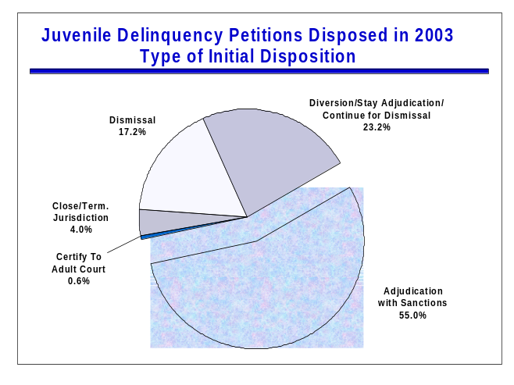
Juvenile Delinquency Petitions Disposed in 2003 Initial Disposition by Petition Type

 | Adjudication w/ Sanctions/Conditions | Certify to Adult Court | Diversion/ Stay Adj. /  Continue for Dism. | Dismiss | Close/ Terminate Jurisdiction
Felony | 56.1% | 1.7% | 28.5% | 10.7% | 3.0%
Gross Misd. | 61.1% | 0.1% | 25.5% | 10.4% | 2.9%
Misd. | 52.9% | 0% | 19.5% | 22.7% | 4.9%
All Types | 55.0% | 0.6% | 23.2% | 17.2% | 4.0%

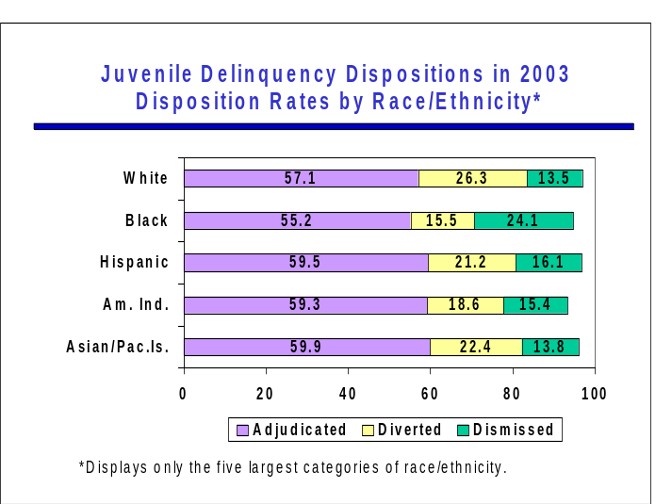In 23% of the dispositions the court continued the case for dismissal, stayed adjudication or ordered the juvenile to participate in a diversion program. This type of disposition frequently includes a variety of care and placement requirements (e.g., treatment, restitution, etc.) as well as requirements such as abstaining from using drugs or alcohol, attending school, and remaining law abiding. Failure to meet the requirements ordered by the court may result in the child being returned to court and adjudicated on the charges. The court may subsequently order additional sanctions or conditions. The remaining 4% of the cases involve case closings or terminations of jurisdiction that did not specifically include a dismissal of the petition or charges.

A comparison of the rates of adjudication shows little variation by race/ethnicity. The highest rate of adjudication is observed for Asian/Pacific Islanders (59.9%), the lowest rate is for blacks (55.2%). Differences by race in the rates of diversion and dismissal are more pronounced. Slightly more than one-quarter of petitions involving white juveniles are diverted (26.3%), continued for dismissal or granted a stay of adjudication compared to 15.5% of petitions involving blacks. On the other hand, 24.1% of cases involving black juveniles are dismissed compared to 13.5% of cases involving white juveniles.

Dispositional Conditions and Sanctions

The most common dispositional conditions ordered by juvenile courts for delinquency petitions in 2003 were financial sanctions (including fines, restitution and community work service), supervision/probation, and evaluation, out-patient treatment or counseling. Letters of apology to victims were also very common (they comprise 28% of the “Other Sanctions” category).

In 24% of the “adjudicated” delinquency petitions for which the court imposed sanctions or care and placement conditions, the court ordered residential facility placement (a state or local facility or some other out-of-home placement). The percentage was much higher for felonies than for gross misdemeanors and misdemeanors (35% as compared to 22% and 17%, respectively).

Petitions Adjudicated/Found Guilty
Percent with Court Ordered Sanctions/Conditions
By Petition Type in 2003

 | Number of Petitions |  | DOC Commitment, Short Term Custody, or Other Out-of-Home Placement | In-Patient Treatment, Evaluation or Outpatient Treatment | Financial Sanctions/ Work Service
Felony | 3,463 |  | 1,198 | 1,244 | 2,545
 |  |  | 34.6% | 35.9% | 73.5%
Gross Misdemeanor | 1,478 |  | 325 | 509 | 1,133
 |  |  | 22.0% | 34.4% | 76.7%
Misdemeanor | 5,527 |  | 960 | 1,755 | 4,175
 |  |  | 17.4% | 31.8% | 75.5%
All Types | 10,468 |  | 2,483 | 3,508 | 7,853
 |  |  | 23.7% | 33.5% | 75.0%

Information on dispositional outcomes by the case type at disposition is displayed in the table below. In interpreting this information, it is important to note that multiple outcomes are possible for a single delinquency petition. For example, a juvenile may be required to be under supervision/probation, to participate in treatment, and also be responsible for financial sanctions such as both fines and restitution. Dispositional outcomes aggregated by judicial district are included in Appendix B.

Petitions Adjudicated/Found Guilty
Number of Dispositional Sanctions or Conditions by Petition Type

 | Number of Petitions |  | DOC Commitment/Jail | DOC Commitment/Jail  - Stayed | Short-Term Custody | Supervision | Evaluation or Outpatient Treatment | In-Patient Treatment | Other Out of Home Placement | Financial Sanctions/ Work Service | Abstain/Random UAs | Other Sanction
Felony | 3,463 |  | 952 | 307 | 206 | 3,056 | 1,220 | 271 | 104 | 3,429 | 1,489 | 3,612
Gross Misdemeanor | 1,478 |  | 258 | 82 | 55 | 1,283 | 543 | 75 | 28 | 1,576 | 443 | 1,444
Misdemeanor | 5,527 |  | 763 | 225 | 127 | 4,532 | 1,784 | 247 | 126 | 5,126 | 1,523 | 5,351
All Types | 10,468 |  | 1,973 | 614 | 388 | 8,871 | 3,538 | 593 | 258 | 10,131 | 3,455 | 10,407
The above table only includes cases for which the court made a finding of guilt either on the case as a whole or for at least one individual count and for which some type of dispositional sanction was pronounced. The table includes only initial dispositional conditions ordered by the court and does not include additional conditions required as a result of violations of the original disposition order. The specific components included in each category are outlined in the table Number of Dispositional Sanctions or Conditions by Judicial District in Appendix B.

Data Sources and Limitations

The data used to prepare this report are primarily from the juvenile datamart maintained by the State Court Administrator’s Office of the Minnesota Supreme Court. The data in the datamart come from the court’s data warehouse, CJAD (Criminal Juvenile Analytical Database). The data warehouse pulls information from TCIS, the statewide case management system used for juvenile cases in all counties except Scott. The only juvenile data available for Scott County in 2003 are the number of filings by type of petition and by race. More detailed case charging information and dispositional data are not available.

In the future, data will be obtained from the MNJAD data mart. MNJAD is the analytical database that will store information from multiple statewide and local systems including TCIS and MNCIS. District courts statewide are currently implementing MNCIS, the new case management system that will replace TCIS. Data on case dispositions in Carver County are not available after January 2003 when Carver County began using MNCIS.

Prior to 2001 this annual report was based on data from the court’s legacy data system, SJIS (State Judicial Information System). The availability of the data warehouse has allowed more detailed information to be included in this report, particularly regarding dispositional outcomes (e.g., SJIS only allowed up to four conditions/sanctions to be entered). However, because of differences in the data sources and the current lack of complete information for the First Judicial District (because of the missing Scott and Carver county data), caution should be used in making comparisons to data appearing in reports prior to 2001.

Juvenile Delinquency Petitions Disposed in CY 2000
Petitions with a Finding/Admission of Guilt on at Least One Count
Dispositional Outcomes/Sanctions By Petition Type
Petition Type at Disposition |  | DOC Commitment/Jail | DOC Commitment/Jail – Stayed | Short-Term Custody | Supervision | Evaluation / Outpatient Treatment | In-Patient Treatment | Other Out of Home Placement | Financial Sanctions | Other Sanctions
Felony |  | 1,034 | 367 | 297 | 3,916 | 1,335 | 316 | 259 | 3,790 | 2,022
Gross Misdemeanor |  | 218 | 76 | 60 | 1,289 | 465 | 68 | 51 | 1,650 | 798
Misdemeanor |  | 755 | 215 | 199 | 5,240 | 2,028 | 222 | 247 | 5,711 | 3,556
Total |  | 2,007 | 658 | 556 | 10,445 | 3,828 | 606 | 557 | 11,151 | 6,376
The outcome categories for cases disposed in calendar year 2000 differ slightly from categories used in earlier legislative reports; in addition, the above figures only represent cases for which there was a finding or admission of guilt for the case as a whole or for at least one individual count. The categories above include the following types of outcomes:
DOC Commitment/Jail: Commitment to a Department of Corrections (DOC) or local facility.
DOC Commitment/Jail – Stayed: Commitments to DOC and local facilities that are stayed.
Short-Term Custody: Jails, lock-ups, and secure detention facilities not included as commitments.
Supervision: Probation, home detention, electronic monitoring, appointment of Guardian ad Litem.
Evaluation/Outpatient Treatment and Inpatient Treatment: Psychiatric, chemical dependency, sex offender or medical. Evaluations are included in the outpatient treatment category.
Other Out of Home Placement: Out of home placements other than jail/DOC commitments.
Financial Sanctions: Fines, restitution, court funds.
Other Sanctions: School attendance, drug testing, driver’s license suspension, no new arrests, no contact orders, and letters of apology. Apology letters account for approximately 1/3 of this category.

Appendices

- Statute A-1

- Tables

Juvenile Petitions Filed in 2003

By County B-1

Type of Petition by Judicial District B-2

Age at Offense by Judicial District B-3

Gender by Judicial District B-4

Judicial District by Race/Ethnicity B-5

Felony Offense Type by Race/Ethnicity B-6

Type of Petition by Alleged Offense Type B-6

Judicial District by Alleged Offense Type B-7

Felony Petition Most Serious Alleged Offense by Judicial District B-8

Juvenile Dispositions

Type of Initial Disposition by Judicial District B-9

Initial Disposition Rates by Race/Ethnicity B-10

Percent with Court-Ordered Sanctions or Conditions by Judicial District B-11

Number of Dispositional Sanctions or Conditions by Judicial District B-12

Appendix A.

260B.173 Report on juvenile delinquency petitions.

The state court administrator shall annually prepare and present to the chairs and ranking minority members of the house judiciary committee and the senate crime prevention committee aggregate data by judicial district on juvenile delinquency petitions. The report must include, but need not be limited to, information on the act for which a delinquency petition is filed, the age of the juvenile, the county where the petition was filed, the outcome of the petition, such as dismissal, continuance for dismissal, continuance without adjudication, and the disposition of the petition such as diversion, detention, probation, restitution, or fine. The report must be prepared on a calendar year basis and be submitted annually beginning July 1, 1999.

HIST: 1999 c 139 art 2 s 22

Appendix B.

Delinquency Petitions Filed in 2003

By County

County | Total Number of Delinquency Petitions |  | County | Total Number of Delinquency Petitions
1 Aitkin | 88 |  | 45 Marshall | 42
2 Anoka | 1,134 |  | 46 Martin | 103
3 Becker | 205 |  | 47 Meeker | 92
4 Beltrami | 301 |  | 48 Mille Lacs | 226
5 Benton | 148 |  | 49 Morrison | 108
6 Bigstone | 26 |  | 50 Mower | 238
7 Blue Earth | 162 |  | 51 Murray | 34
8 Brown | 102 |  | 52 Nicollet | 112
9 Carlton | 186 |  | 53 Nobles | 72
10 Carver | 368 |  | 54 Norman | 29
11 Cass | 310 |  | 55 Olmsted | 343
12 Chippewa | 33 |  | 56 Otter Tail | 168
13 Chisago | 191 |  | 57 Pennington | 84
14 Clay | 221 |  | 58 Pine | 165
15 Clearwater | 86 |  | 59 Pipestone | 25
16 Cook | 13 |  | 60 Polk | 145
17 Cottonwood | 68 |  | 61 Pope | 29
18 Crow Wing | 218 |  | 62 Ramsey | 2,489
19 Dakota | 2,081 |  | 63 Red Lake | 20
20 Dodge | 105 |  | 64 Redwood | 99
21 Douglas | 97 |  | 65 Renville | 64
22 Faribault | 86 |  | 66 Rice | 214
23 Fillmore | 57 |  | 67 Rock | 47
24 Freeborn | 199 |  | 68 Roseau | 84
25 Goodhue | 248 |  | 69 St. Louis | 997
26 Grant | 26 |  | 70 Scott | 831
27 Hennepin | 4,436 |  | 71 Sherburne | 333
28 Houston | 57 |  | 72 Sibley | 91
29 Hubbard | 176 |  | 73 Stearns | 590
30 Isanti | 179 |  | 74 Steele | 156
31 Itasca | 387 |  | 75 Stevens | 17
32 Jackson | 24 |  | 76 Swift | 102
33 Kanabec | 87 |  | 77 Todd | 102
34 Kandiyohi | 262 |  | 78 Traverse | 6
35 Kittson | 4 |  | 79 Wabasha | 47
36 Koochiching | 71 |  | 80 Wadena | 60
37 Lac Qui Parle | 23 |  | 81 Waseca | 52
38 Lake | 26 |  | 82 Washington | 481
39 Lake of the Woods | 27 |  | 83 Watonwan | 91
40 Le Sueur | 208 |  | 84 Wilkin | 41
41 Lincoln | 8 |  | 85 Winona | 187
42 Lyon | 80 |  | 86 Wright | 452
43 Mcleod | 280 |  | 87 Yellow Medicine | 30
44 Mahnomen | 287
 |  |  | Statewide | 23,079

Juvenile Delinquency Petitions Filed in 2003

Type of Petition by Judicial District

 |  | Type of Delinquency Petition
Judicial District |  | Felony | Gross  Misd | Misd | Total Petitions
1 | # | 923 | 322 | 2862 | 4107
 | % | 22.5% | 7.8% | 69.7% | 100.0%
2 | # | 868 | 340 | 1281 | 2489
 | % | 34.9% | 13.7% | 51.5% | 100.0%
3 | # | 758 | 148 | 749 | 1655
 | % | 45.8% | 8.9% | 45.3% | 100.0%
4 | # | 1656 | 481 | 2299 | 4436
 | % | 37.3% | 10.8% | 51.8% | 100.0%
5 | # | 449 | 114 | 550 | 1113
 | % | 40.3% | 10.2% | 49.4% | 100.0%
6 | # | 437 | 87 | 698 | 1222
 | % | 35.8% | 7.1% | 57.1% | 100.0%
7 | # | 765 | 173 | 987 | 1925
 | % | 39.7% | 9.0% | 51.3% | 100.0%
8 | # | 305 | 77 | 369 | 751
 | % | 40.6% | 10.3% | 49.1% | 100.0%
9 | # | 812 | 172 | 1375 | 2359
 | % | 34.4% | 7.3% | 58.3% | 100.0%
10 | # | 1225 | 370 | 1427 | 3022
 | % | 40.5% | 12.2% | 47.2% | 100.0%
Statewide | # | 8198 | 2284 | 12597 | 23079
 | % | 35.5% | 9.9% | 54.6% | 100.0%

Juvenile Delinquency Petitions Filed in 2003

Age at Offense by Judicial District
Judicial District | 10 | 11 | 12 | 13 | 14 | 15 | 16 | 17 | Unknown/Missing | Total
1* | 31 | 75 | 147 | 306 | 455 | 601 | 813 | 826 | 22 | 3276
 | 1.0% | 2.3% | 4.5% | 9.3% | 13.9% | 18.3% | 24.8% | 25.2% | 0.7% | 100.0%
2 | 46 | 77 | 121 | 269 | 425 | 550 | 480 | 512 | 9 | 2489
 | 1.8% | 3.1% | 4.9% | 10.8% | 17.1% | 22.1% | 19.3% | 20.6% | 0.4% | 100.0%
3 | 12 | 30 | 84 | 144 | 221 | 309 | 415 | 426 | 14 | 1655
 | 0.7% | 1.8% | 5.1% | 8.7% | 13.4% | 18.7% | 25.1% | 25.7% | 0.8% | 100.0%
4 | 43 | 84 | 242 | 513 | 645 | 829 | 1081 | 992 | 7 | 4436
 | 1.0% | 1.9% | 5.5% | 11.6% | 14.5% | 18.7% | 24.4% | 22.4% | 0.2% | 100.0%
5 | 20 | 42 | 70 | 134 | 152 | 176 | 237 | 278 | 4 | 1113
 | 1.8% | 3.8% | 6.3% | 12.0% | 13.7% | 15.8% | 21.3% | 25.0% | 0.4% | 100.0%
6 | 12 | 25 | 53 | 124 | 170 | 251 | 279 | 302 | 6 | 1222
 | 1.0% | 2.0% | 4.3% | 10.1% | 13.9% | 20.5% | 22.8% | 24.7% | 0.5% | 100.0%
7 | 20 | 56 | 92 | 156 | 264 | 376 | 475 | 473 | 13 | 1925
 | 1.0% | 2.9% | 4.8% | 8.1% | 13.7% | 19.5% | 24.7% | 24.6% | 0.7% | 100.0%
8 | 13 | 24 | 53 | 65 | 107 | 123 | 172 | 187 | 7 | 751
 | 1.7% | 3.2% | 7.1% | 8.7% | 14.2% | 16.4% | 22.9% | 24.9% | 0.9% | 100.0%
9 | 14 | 50 | 129 | 265 | 366 | 433 | 519 | 581 | 2 | 2359
 | 0.6% | 2.1% | 5.5% | 11.2% | 15.5% | 18.4% | 22.0% | 24.6% | 0.1% | 100.0%
10 | 17 | 70 | 143 | 264 | 452 | 528 | 729 | 801 | 18 | 3022
 | 0.6% | 2.3% | 4.7% | 8.7% | 15.0% | 17.5% | 24.1% | 26.5% | 0.6% | 100.0%
Statewide | 228 | 533 | 1134 | 2240 | 3257 | 4176 | 5200 | 5378 | 102 | 22248
 | 1.0% | 2.4% | 5.1% | 10.1% | 14.6% | 18.8% | 23.4% | 24.2% | 0.5% | 100.0%
* Totals for the First District do not include filings in Scott County. Detailed information on Scott County filings is not available

.

Juvenile Delinquency Petitions Filed in 2003

Gender by Judicial District

Judicial District | Male | Female | Unknown/Missing | Total
1* | 2361 | 887 | 28 | 3276
 | 72.1% | 27.1% | 0.9% | 100.0%
2 | 1830 | 654 | 5 | 2489
 | 73.5% | 26.3% | 0.2% | 100.0%
3 | 1273 | 369 | 13 | 1655
 | 76.9% | 22.3% | 0.8% | 100.0%
4 | 3485 | 945 | 6 | 4436
 | 78.6% | 21.3% | 0.1% | 100.0%
5 | 826 | 264 | 23 | 1113
 | 74.2% | 23.7% | 2.1% | 100.0%
6 | 923 | 299 | 0 | 1222
 | 75.5% | 24.5% | 0.0% | 100.0%
7 | 1534 | 383 | 8 | 1925
 | 79.7% | 19.9% | 0.4% | 100.0%
8 | 590 | 159 | 2 | 751
 | 78.6% | 21.2% | 0.3% | 100.0%
9 | 1730 | 615 | 14 | 2359
 | 73.3% | 26.1% | 0.6% | 100.0%
10 | 2398 | 621 | 3 | 3022
 | 79.4% | 20.5% | 0.1% | 100.0%
Statewide | 16950 | 5196 | 102 | 22,248
 | 76.2% | 23.4% | 0.5% | 100.0%

* Totals for the First District do not include filings in Scott County.
Detailed information on Scott County filings is not available.
Juvenile Delinquency Petitions Filed in 2003
Judicial District by Race/Ethnicity

District | White | Black | American Indian | Hispanic | Asian/Pacific Islander | Multiple Races | Other | Refused | Missing | Total
1* | 1825 | 369 | 26 | 121 | 89 | 45 | 28 | 0 | 1604 | 4107
 | 44.4% | 9.0% | 0.6% | 2.9% | 2.2% | 1.1% | 0.7% | 0.0% | 39.1% | 100.0%
2 | 835 | 981 | 52 | 213 | 284 | 82 | 13 | 4 | 25 | 2489
 | 33.5% | 39.4% | 2.1% | 8.6% | 11.4% | 3.3% | 0.5% | 0.2% | 1.0% | 100.0%
3 | 1078 | 116 | 10 | 198 | 42 | 27 | 15 | 8 | 161 | 1655
 | 65.1% | 7.0% | 0.6% | 12.0% | 2.5% | 1.6% | 0.9% | 0.5% | 9.7% | 100.0%
4 | 1255 | 2276 | 215 | 134 | 261 | 83 | 14 | 10 | 188 | 4436
 | 28.3% | 51.3% | 4.8% | 3.0% | 5.9% | 1.9% | 0.3% | 0.2% | 4.2% | 100.0%
5 | 675 | 53 | 55 | 119 | 32 | 16 | 8 | 2 | 153 | 1113
 | 60.6% | 4.8% | 4.9% | 10.7% | 2.9% | 1.4% | 0.7% | 0.2% | 13.7% | 100.0%
6 | 724 | 36 | 234 | 34 | 6 | 43 | 0 | 12 | 133 | 1222
 | 59.2% | 2.9% | 19.1% | 2.8% | 0.5% | 3.5% | 0.0% | 1.0% | 10.9% | 100.0%
7 | 1118 | 101 | 207 | 84 | 12 | 49 | 14 | 96 | 244 | 1925
 | 58.1% | 5.2% | 10.8% | 4.4% | 0.6% | 2.5% | 0.7% | 5.0% | 12.7% | 100.0%
8 | 456 | 14 | 31 | 166 | 1 | 5 | 4 | 0 | 74 | 751
 | 60.7% | 1.9% | 4.1% | 22.1% | 0.1% | 0.7% | 0.5% | 0.0% | 9.9% | 100.0%
9 | 1028 | 11 | 656 | 87 | 14 | 94 | 7 | 27 | 435 | 2359
 | 43.6% | 0.5% | 27.8% | 3.7% | 0.6% | 4.0% | 0.3% | 1.1% | 18.4% | 100.0%
10 | 2148 | 245 | 72 | 46 | 76 | 49 | 8 | 17 | 361 | 3022
 | 71.1% | 8.1% | 2.4% | 1.5% | 2.5% | 1.6% | 0.3% | 0.6% | 11.9% | 100.0%
Statewide | 11142 | 4202 | 1558 | 1202 | 817 | 493 | 111 | 176 | 3378 | 23079
 | 48.3% | 18.2% | 6.8% | 5.2% | 3.5% | 2.1% | 0.5% | 0.8% | 14.6% | 100.0%

* Limited information on race is available for filings in Scott County. All filings in Carver County are included in the missing category.

Felony Juvenile Delinquency Petitions Filed in 2003
Offense Type by Race/Ethnicity
Offense Type | White | Black | American Indian | Hispanic | Asian/Pacific Islander | Multiple Races | Other | Refused | Missing | Total
Person | 1018 | 521 | 147 | 115 | 77 | 47 | 9 | 13 | 191 | 2138
 | 47.6% | 24.4% | 6.9% | 5.4% | 3.6% | 2.2% | 0.4% | 0.6% | 8.9% | 100.0%
Property | 2750 | 558 | 274 | 207 | 245 | 79 | 11 | 52 | 451 | 4627
 | 59.4% | 12.1% | 5.9% | 4.5% | 5.3% | 1.7% | 0.2% | 1.1% | 9.7% | 100.0%
Drugs | 308 | 147 | 23 | 32 | 11 | 8 | 3 | 2 | 40 | 574
 | 53.7% | 25.6% | 4.0% | 5.6% | 1.9% | 1.4% | 0.5% | 0.3% | 7.0% | 100.0%
Other | 299 | 127 | 48 | 32 | 33 | 7 | 2 | 3 | 49 | 600
 | 49.8% | 21.2% | 8.0% | 5.3% | 5.5% | 1.2% | 0.3% | 0.5% | 8.2% | 100.0%
Total* | 4375 | 1353 | 492 | 386 | 366 | 141 | 25 | 70 | 731 | 7939
 | 55.1% | 17.0% | 6.2% | 4.9% | 4.6% | 1.8% | 0.3% | 0.9% | 9.2% | 100.0%

* Detailed information on Scott County filings is not available.

Juvenile Delinquency Petitions Filed in 2003
Type of Delinquency Petition by Alleged Offense Type
(most serious alleged offense)

 | Offense Category
Type of Petition | Person | Property | Drugs | Other | Unknown/Missing* | Total
Felony | 2138 | 4627 | 574 | 600 | 259 | 8198
 | 26.1% | 56.4% | 7.0% | 7.3% | 3.2% | 100.0%
Gross Misd. | 458 | 992 | 5 | 725 | 104 | 2284
 | 20.1% | 43.4% | 0.2% | 31.7% | 4.6% | 100.0%
Misd. | 4357 | 3779 | 119 | 3532 | 810 | 12597
 | 34.6% | 30.0% | 0.9% | 28.0% | 6.4% | 100.0%
Total* | 6953 | 9398 | 698 | 4857 | 1173 | 23079
 | 30.1% | 40.7% | 3.0% | 21.0% | 5.1% | 100.0%

* Detailed information on filings in Scott and Carver counties are not available.

Juvenile Delinquency Petitions Filed in 2003
Judicial District by Alleged Offense Type
(most serious alleged offense)

 | Offense Category
Judicial District | Person | Property | Drugs | Other | Total
1* | 676 | 1464 | 78 | 716 | 2934
 | 23.0% | 49.9% | 2.7% | 24.4% | 100.0%
2 | 753 | 1025 | 66 | 645 | 2489
 | 30.3% | 41.2% | 2.7% | 25.9% | 100.0%
3 | 579 | 718 | 64 | 294 | 1655
 | 35.0% | 43.4% | 3.9% | 17.8% | 100.0%
4 | 1672 | 1599 | 179 | 986 | 4436
 | 37.7% | 36.0% | 4.0% | 22.2% | 100.0%
5 | 417 | 479 | 19 | 198 | 1113
 | 37.5% | 43.0% | 1.7% | 17.8% | 100.0%
6 | 349 | 506 | 51 | 316 | 1222
 | 28.6% | 41.4% | 4.2% | 25.9% | 100.0%
7 | 669 | 846 | 60 | 350 | 1925
 | 34.8% | 43.9% | 3.1% | 18.2% | 100.0%
8 | 215 | 378 | 16 | 142 | 751
 | 28.6% | 50.3% | 2.1% | 18.9% | 100.0%
9 | 650 | 1043 | 64 | 602 | 2359
 | 27.6% | 44.2% | 2.7% | 25.5% | 100.0%
10 | 973 | 1340 | 101 | 608 | 3022
 | 32.2% | 44.3% | 3.3% | 20.1% | 100.0%
Statewide | 6953 | 9398 | 698 | 4857 | 21906
 | 31.7% | 42.9% | 3.2% | 22.2% | 100.0%

* Totals for the First District do not include filings in Scott or Carver counties. Detailed information on filings in Scott and Carver counties are not available.

Felony Juvenile Delinquency Petitions Filed in 2003

Most Serious Alleged Offense
Judicial District | Theft/Stolen Property | Burglary | Assault | Property Dmg/Trespass | Drugs | Sex Offense | Weapons | Robbery | Homicide | Other | Total
1* | 178 | 111 | 69 | 96 | 63 | 56 | 31 | 14 | 0 | 46 | 664
 | 26.8% | 16.7% | 10.4% | 14.5% | 9.5% | 8.4% | 4.7% | 2.1% | 0.0% | 6.9% | 100.0%
2 | 238 | 145 | 111 | 110 | 55 | 41 | 42 | 60 | 3 | 63 | 868
 | 27.4% | 16.7% | 12.8% | 12.7% | 6.3% | 4.7% | 4.8% | 6.9% | 0.3% | 7.3% | 100.0%
3 | 204 | 167 | 94 | 92 | 58 | 47 | 18 | 18 | 1 | 59 | 758
 | 26.9% | 22.0% | 12.4% | 12.1% | 7.7% | 6.2% | 2.4% | 2.4% | 0.1% | 7.8% | 100.0%
4 | 459 | 208 | 265 | 131 | 164 | 77 | 98 | 131 | 7 | 116 | 1656
 | 27.7% | 12.6% | 16.0% | 7.9% | 9.9% | 4.6% | 5.9% | 7.9% | 0.4% | 7.0% | 100.0%
5 | 90 | 128 | 71 | 55 | 15 | 30 | 21 | 4 | 2 | 33 | 449
 | 20.0% | 28.5% | 15.8% | 12.2% | 3.3% | 6.7% | 4.7% | 0.9% | 0.4% | 7.3% | 100.0%
6 | 100 | 106 | 47 | 55 | 28 | 22 | 10 | 11 | 2 | 56 | 437
 | 22.9% | 24.3% | 10.8% | 12.6% | 6.4% | 5.0% | 2.3% | 2.5% | 0.5% | 12.8% | 100.0%
7 | 248 | 184 | 82 | 77 | 55 | 47 | 7 | 8 | 5 | 52 | 765
 | 32.4% | 24.1% | 10.7% | 10.1% | 7.2% | 6.1% | 0.9% | 1.0% | 0.7% | 6.8% | 100.0%
8 | 62 | 101 | 44 | 32 | 9 | 23 | 4 | 2 | 2 | 26 | 305
 | 20.3% | 33.1% | 14.4% | 10.5% | 3.0% | 7.5% | 1.3% | 0.7% | 0.7% | 8.5% | 100.0%
9 | 180 | 249 | 105 | 85 | 38 | 55 | 21 | 8 | 3 | 68 | 812
 | 22.2% | 30.7% | 12.9% | 10.5% | 4.7% | 6.8% | 2.6% | 1.0% | 0.4% | 8.4% | 100.0%
10 | 322 | 269 | 148 | 136 | 89 | 73 | 54 | 19 | 2 | 113 | 1225
 | 26.3% | 22.0% | 12.1% | 11.1% | 7.3% | 6.0% | 4.4% | 1.6% | 0.2% | 9.2% | 100.0%
Statewide | 2081 | 1668 | 1036 | 869 | 574 | 471 | 306 | 275 | 27 | 632 | 7939
 | 26.2% | 21.0% | 13.0% | 10.9% | 7.2% | 5.9% | 3.9% | 3.5% | 0.3% | 8.0% | 100.0%

Totals for the First District do not include filings in Scott and Carver counties. Detailed information on filings in Scott and Carver counties are not available.

Delinquency Petitions Disposed in 2003
Type of Initial Disposition by Judicial District

Judicial District | Total Petitions Disposed | Adjudication w/ Sanctions | Diversion, Stay of Adjudication or Cont for Dismissal | Dismissed | Certification to Adult Court | Other Case Closure or Jurisdiction Terminated
1* | 2608 | 959 | 786 | 741 | 5 | 117
 |  | 36.8% | 30.1% | 28.4% | 0.2% | 4.5%
2 | 2076 | 900 | 692 | 289 | 13 | 182
 |  | 43.4% | 33.3% | 13.9% | 0.6% | 8.8%
3 | 1556 | 1036 | 283 | 195 | 8 | 34
 |  | 66.6% | 18.2% | 12.5% | 0.5% | 2.2%
4 | 3840 | 2400 | 341 | 960 | 30 | 109
 |  | 62.5% | 8.9% | 25.0% | 0.8% | 2.8%
5 | 1011 | 624 | 229 | 128 | 4 | 26
 |  | 61.7% | 22.7% | 12.7% | 0.4% | 2.6%
6 | 1179 | 705 | 335 | 101 | 15 | 23
 |  | 59.8% | 28.4% | 8.6% | 1.3% | 2.0%
7 | 1643 | 995 | 334 | 183 | 5 | 126
 |  | 60.6% | 20.3% | 11.1% | 0.3% | 7.7%
8 | 614 | 293 | 194 | 91 | 4 | 32
 |  | 47.7% | 31.6% | 14.8% | 0.7% | 5.2%
9 | 1980 | 960 | 676 | 267 | 17 | 60
 |  | 48.5% | 34.1% | 13.5% | 0.9% | 3.0%
10 | 2529 | 1596 | 547 | 322 | 6 | 58
 |  | 63.1% | 21.6% | 12.7% | 0.2% | 2.3%
Statewide | 19036 | 10468 | 4417 | 3277 | 107 | 767
 |  | 55.0% | 23.2% | 17.2% | 0.6% | 4.0%

* Totals for the First Judicial District do not include dispositions in Scott or Carver counties. Data on juvenile dispositions in Scott and Carver counties are not available.

Juvenile Delinquency Petitions Disposed in 2003

Initial Disposition Rates by Race/Ethnicity

Race/ Ethnicity | Total | Adjudicated with Sanctions | Diversion,  Stay of Adjudication or Continued for Dismissal | Dismissed | Certification | Other Case Closure or Jurisdiction Terminated
White | 9946 | 5683 | 2613 | 1339 | 39 | 272
 |  | 57.1% | 26.3% | 13.5% | 0.4% | 2.7%
Black | 3577 | 1975 | 554 | 862 | 28 | 158
 |  | 55.2% | 15.5% | 24.1% | 0.8% | 4.4%
American  Indian | 1406 | 834 | 262 | 217 | 21 | 72
 |  | 59.3% | 18.6% | 15.4% | 1.5% | 5.1%
Hispanic | 1030 | 613 | 218 | 166 | 2 | 31
 |  | 59.5% | 21.2% | 16.1% | 0.2% | 3.0%
Asian/Pacific  Islander | 710 | 425 | 159 | 98 | 5 | 23
 |  | 59.9% | 22.4% | 13.8% | 0.7% | 3.2%
Multiple Races | 443 | 254 | 91 | 78 | 2 | 18
 |  | 57.3% | 20.5% | 17.6% | 0.5% | 4.1%
Other | 87 | 52 | 24 | 10 | 0 | 1
 |  | 59.8% | 27.6% | 11.5% | 0.0% | 1.1%
Refused | 156 | 92 | 37 | 15 | 0 | 12
 |  | 59.0% | 23.7% | 9.6% | 0.0% | 7.7%
Missing | 1681 | 540 | 459 | 492 | 10 | 180
 |  | 32.1% | 27.3% | 29.3% | 0.6% | 10.7%
Total | 19036 | 10468 | 4417 | 3277 | 107 | 767
 |  | 55.0% | 23.2% | 17.2% | 0.6% | 4.0%

Totals do not include dispositions in Scott County or dispositions after January 2003 in Carver County. Data on juvenile dispositions in Scott County are not available.

Juvenile Delinquency Petitions Disposed in 2003
Petitions Adjudicated/Found Guilty
Percent with Court-Ordered Sanctions or Conditions by Judicial District

Judicial District | Number of Petitions | DOC Commitment, Short Term Custody, or Other Out-of-Home Placement | In-Patient Treatment, Evaluation or Outpatient Treatment | Financial Sanctions/ Work Service
1* | 959 | 246 | 361 | 679
 |  | 25.7% | 37.6% | 70.8%
2 | 900 | 416 | 320 | 526
 |  | 46.2% | 35.6% | 58.4%
3 | 1036 | 106 | 225 | 891
 |  | 10.2% | 21.7% | 86.0%
4 | 2400 | 459 | 951 | 1825
 |  | 19.1% | 39.6% | 76.0%
5 | 624 | 72 | 208 | 539
 |  | 11.5% | 33.3% | 86.4%
6 | 705 | 186 | 186 | 515
 |  | 26.4% | 26.4% | 73.0%
7 | 995 | 201 | 349 | 800
 |  | 20.2% | 35.1% | 80.4%
8 | 293 | 77 | 84 | 234
 |  | 26.3% | 28.7% | 79.9%
9 | 960 | 172 | 215 | 746
 |  | 17.9% | 22.4% | 77.7%
10 | 1596 | 548 | 609 | 1098
 |  | 34.3% | 38.2% | 68.8%
Statewide | 10468 | 2483 | 3508 | 7853
 |  | 23.7% | 33.5% | 75.0%

*Totals for the First Judicial District do not include dispositions in Scott County or dispositions in Carver County after January 2003. Data on juvenile dispositions in Scott and Carver counties are currently not available.

Juvenile Delinquency Petitions Disposed in 2003
Petitions Adjudicated/Found Guilty
Number of Dispositional Sanctions or Conditions by Judicial District
Judicial District |  | Number of Petitions | DOC Commitment/Jail | DOC Commitment/Jail – Stayed | Short-Term Custody | Supervision | Evaluation / Outpatient Treatment | In-Patient Treatment | Other Out of Home Placement | Financial Sanctions/ Community Work Service | Abstain/Random UAs | Other Sanctions
1* |  | 959 | 223 | 41 | 22 | 900 | 310 | 163 | 6 | 876 | 345 | 1458
2 |  | 900 | 345 | 41 | 65 | 886 | 366 | 13 | 19 | 641 | 167 | 458
3 |  | 1036 | 90 | 8 | 5 | 953 | 221 | 43 | 15 | 1248 | 623 | 1200
4 |  | 2400 | 345 | 195 | 122 | 1718 | 931 | 146 | 37 | 2498 | 284 | 2069
5 |  | 624 | 54 | 67 | 11 | 562 | 200 | 50 | 10 | 778 | 298 | 927
6 |  | 705 | 162 | 42 | 27 | 617 | 185 | 35 | 9 | 617 | 217 | 543
7 |  | 995 | 159 | 46 | 29 | 875 | 345 | 54 | 18 | 1001 | 386 | 727
8 |  | 293 | 60 | 29 | 15 | 251 | 85 | 11 | 4 | 302 | 110 | 404
9 |  | 960 | 100 | 67 | 32 | 739 | 191 | 45 | 42 | 904 | 110 | 658
10 |  | 1596 | 435 | 78 | 60 | 1370 | 704 | 33 | 98 | 1266 | 915 | 1963
Statewide |  | 10468 | 1973 | 614 | 388 | 8871 | 3538 | 593 | 258 | 10131 | 3455 | 10407
* Totals for the First Judicial District do not include dispositions in Scott County or dispositions in Carver County after January 2003. Data on juvenile dispositions in Scott and Carver counties are not currently available.

The table does not include sanctions or conditions required as a result of violations of the initial disposition order. The categories include the following types of outcomes:
DOC Commitment/Jail: Commitment to a Department of Corrections (DOC) or local facility.
DOC Commitment/Jail – Stayed: Commitments to DOC and local facilities that are stayed.
Short-Term Custody: Jails, lock-ups, and secure detention facilities not included as commitments.
Supervision: Probation, home detention, electronic monitoring, appointment of Guardian ad Litem.
Evaluation/Outpatient Treatment and Inpatient Treatment: Psychiatric, chemical dependency, sex offender or medical. Evaluations are included in the outpatient treatment category.
Other Out of Home Placement: Out of home placements other than jail/DOC commitments.
Financial Sanctions: Fines, restitution, court funds, community work service.
Other Sanctions: School attendance, drug testing, driver’s license suspension, no new arrests, no contact orders, letters of apology to victim.

Minnesota Rules of Juvenile Procedure 6.02 and 6.03

