Minnesota’s Court Performance in Child Protection Cases:
A Reassessment Under the Federal Court Improvement Program

December 2005

Minnesota Supreme Court
State Court Administrator’s Office
Court Services Division
105 Minnesota Judicial Center
25 Rev. Dr. Martin Luther King Jr. Blvd.
St. Paul, MN 55155
651-297-7581

Chapter 1: Reassessment Purpose and Overview 2
- Increased Judicial Oversight Role in Child Protection Cases 2
- Overview of Federal State Court Improvement Program (CIP) 3
- Overview of Report 4

Chapter 2: Methodology 5
- Overview of Methodology 5
- Review of Statutes and Rules 5
- File Reviews, Hearing Observations, and Stakeholder Interviews 6
- Examination of Data from Court’s Automated Statewide Database 7
- Examination of Data from DHS’ Automated Statewide Database 7
- Review of Findings from CFRS and Title IV-E Reviews 8

Chapter 3: Overview of Children’s Justice Initiative 9
- Objective: Safe, Stable, Permanent Homes for Abused and Neglected Children 9
- Statewide Participation of All Counties 9
- Lead Judges and County Teams 9
- Kick-Off Conferences 9
- County Practice Guide and County Action Plans 10
- Performance measures 10

Chapter 4: Juvenile Code Consistency with Federal Statutes 11

Chapter 5: Child Protection System Court Process – Update of Findings
In 1997 Initial Assessment and 2005 Reassessment Findings 15

Maltreatment Reports and Determinations 15
- CHIPS Petition 19
- Adjudication 19
- Disposition and Out-of-Home Placement 21
- Review of Disposition 26
- Permanency Determination 27
- Adoptions 32

Chapter 6: Update of General Findings From 1997 Initial Assessment 37
- Funding Streams 37
- Representation of Children and Parents 37
- Publically Accessible Hearings and Records 40
- Continuity and Case Management 41

Chapter 7: Update of Findings from CFSR and Title IV-E Reviews 42
- Children and Family Services Review 42
- Title IV-E Federal Foster Care Eligibility Review 49

Chapter 8: CIP Reform Efforts 52

Appendices (attached separately)
A. Increased Judicial Oversight in Child Protection Matters

Courts have an enormous oversight responsibility in child protection matters. Along with child welfare agencies, courts have an obligation to ensure that victims of abuse and neglect are protected from harm. Courts determine whether abuse or neglect has occurred and whether a child can be safely maintained at home or must be removed from home and placed in foster care. Courts regularly review cases to decide whether parents are making progress on their case plans. Courts oversee the efforts of social services agencies to rehabilitate families or, where necessary, to provide permanent alternative homes for child victims. Courts are required to ensure that children leave foster care for safe and permanent homes within statutory timeframes. And, courts have the difficult task of determining if and when a parent’s rights should be permanently terminated and whether a child should be adopted or placed with a permanent legal custodian.

Over the past 25 years, the oversight role of juvenile court judges has increased significantly as a result of changes to federal and state laws. The National Council of Juvenile and Family Court Judges (NCJFCJ) summarizes the evolution as follows:

As recently as the 1970s, juvenile and family courts were expected only to determine whether a child had been abused or neglected and, if so, whether the child needed to be removed from home or placed under court or agency supervision. Children were often being removed from their homes unnecessarily and children who could not be safely returned home lingered in temporary care for years. These children endured multiple placements and often aged out of the child welfare system without family ties and with inadequate skills to function as adults. Court involvement in cases was often a “rubber stamp” for agency recommendations and plans.

During the 1980s, with the implementation of the Adoption Assistance and Child Welfare Act of 1980, juvenile and family court judges became responsible for ensuring that a safe, permanent, and stable home was secured for each abused or neglected child coming before the court. The law required courts to evaluate the reasonableness of services provided to preserve families, to hold periodic review hearings in foster care cases, to adhere to deadlines for permanency planning decisions, and to comply with procedural safeguards concerning placement and visitation.

By the early 1990s, most juvenile courts were beginning to recognize the need for timely decision-making and active case oversight for abused and neglected children. . . . .

The increased oversight role of judges in child protection cases established a need to assess their responsibilities and also assess courts’ case management practices and procedures.

B. Overview of Federal Court Improvement Program (CIP)

1. Establishment and Purpose of the Court Improvement Program (CIP)

In light of the increasing oversight role of juvenile court judges in child protection cases, and given the desire and need to improve juvenile court system practices and procedures, the federal State Court Improvement Program (CIP) was implemented in the late 1990s.

The CIP was created as part of the federal Omnibus Budget Reconciliation Act of 1993 which, among other things, provided federal funds to state child welfare agencies and tribes for preventative services and services to families at risk or in crisis. In 1995, the Act designated a portion of these funds as grants to state courts to create collaborative teams to assess their foster care and adoption laws and judicial processes, and to develop and implement a plan for improving court system practices and procedures. The Adoption and Safe Families Act (ASFA) of 1997 reauthorized the CIP. The Promoting Safe and Stable Families Act of 2001 reauthorized the CIP through 2006. The 2001 Act also expanded the scope of the CIP to require states to: (1) include improvements that the highest court in each state deemed necessary to provide for the safety, well-being, and permanence of children in foster care; and (2) implement a corrective action plan as deemed necessary in response to findings identified in the Child and Family Services Review (CFSR) of the state’s child welfare system.

- Requirement of CIP Assessment and Reassessment

In order to receive federal CIP grant funds, in the mid-1990s state courts were required to conduct an assessment regarding the performance of their court’s child protection system procedures and practices. In March 2003, a Program Instruction from the Administration for Children and Families (ACF) notified state courts that they were required to conduct a reassessment to: (1) update their earlier findings regarding their court system’s performance regarding child protection matters; (2) provide information regarding the state’s implementation of the ASFA legislation; and (3) provide an update regarding the state’s CIP reform efforts.

- Minnesota’s 1997 Assessment and 2005 Reassessment

Consistent with the federal requirement to conduct an assessment, in October 1995 the Minnesota Supreme Court established the Foster Care and Adoption Task Force to, among other things: (1) identify court rules, standards, procedures, and policies designed to achieve safe, timely, and permanent homes for abused and neglected children; and (2) evaluate the performance of the judicial system regarding child protection proceedings. In January 1997, the Task Force report [hereinafter “Initial Assessment”] was submitted to the Minnesota Supreme Court and the federal Administration for Children and Families.
As required under the 2003 ACF Program Instruction, this Reassessment updates the findings from the 1997 Initial Assessment. It also includes strengths and weaknesses related to court system’s practices and procedures reflected in the Children and Family Service Review (CFRS) conducted in Minnesota 2001 and the Title IV-E federal foster care eligibility review conducted in Minnesota in 2004. Finally, this Reassessment includes findings regarding the improvements resulting from the statewide implementation of the Children’s Justice Initiative, discussed in more detail in Chapter 3.

C. Overview of Report

This Case Management Review report is organized into five chapters, including this Reassessment Purpose and Overview.

Chapter 2, Methodology, describes the types of activities under taken to gather information for this report, including review of federal and state statutes and rules, review of data from the Court’s and the Department of Human Services’ (DHS) automated statewide databases, file reviews, hearing observations, interviews of stakeholders,.

Chapter 3, Children’s Justice Initiative (CJI) Overview, describes the CJI including its purpose and mission, lead judges, county teams, kick-off conferences, County Practice Guide, and County Action Plan.

Chapter 4, Juvenile Code Consistency with Federal Statutes, compares Minnesota’s Juvenile Code to the federal statutes relating to child protection matters.

Chapter 5, Child Protection System Court Process – Update of Findings In 1997 Initial Assessment and 2005 Reassessment Findings sets forth findings regarding the court process related to Maltreatment Reports and Determinations, Petitions, Adjudication, Disposition and Out-of-Home Placement, Review of Disposition, Permanency Determination, and Adoption.

Chapter 6: Update of General Findings From Initial Assessment sets forth findings regarding Funding Streams, Representation of Children and Parents, Publically Accessible Hearings and Records, and Continuity and Case Management.

Chapter 7: Update of Findings from CFSR and Title IV-E Reviews describes the process and findings regarding Minnesota’s Children and Family Services Review conducted in 2001 and Title IV-E Federal Foster Care Eligibility Review conducted in 2004.

Chapter 8: CIP Reform Efforts identifies the ongoing efforts to be made by CIP staff to continue making improvements in outcomes for abused and neglected children, including model order templates, judges benchbook, training, performance measures, and amendment of statutes and rules.

Appendices include the CJI Practice Guide (Appendix A) and the CJI Performance Measures (Appendix B).

- Overview of Methodology

Three broad processes were used to conduct the Reassessment: (1) identification of the federal and state requirements and standards for which the court is responsible in child protection matters; (2) collection of information about the extent to which those requirements and standards are being met; and (3) examination of that information to determine the court system’s strengths and weaknesses. Information derived from a series of activities was synthesized to provide the overall Reassessment analysis. Those activities included:

- Review of the federal and state rules and statutes related to court processes and procedures in child protection cases;

- Analysis of data from case management reviews conducted in the first 27 Children’s Justice Initiative (CJI) counties;

- Examination of data from the court’s automated statewide information system;

- Examination of data from the Minnesota Department of Human Services’ automated statewide information system;

- Review of the findings and the Program Improvement Plan from Minnesota’s 2001 Children and Family Services Review (CFSR); and

- Review of the findings from the 2004 Title IV-E federal foster care eligibility review.

The following sections provide a more detailed explanation of the methodologies employed.

- Review of Rules and Statutes

Since completion of the Initial Assessment in 1997, Minnesota’s court system has undertaken several reviews of the federal and state statutes and rules, as well as standards recommended by national organizations, regarding child protection matters. One of the reviews was conducted as part of the overhaul of Minnesota’s Rules of Juvenile Protection Procedure that commenced in 1998 and resulted in promulgation of new rules in 2000. Another review was commenced in 2002 as part of the CJI Case Management Review process (discussed below in more detail). The various reviews resulted in identification of federal and state statutes, rules, and national standards applicable to courts in child protection cases (see Chapter 4). In turn, this information served to identify the types of data to be collected and formed the basis by which the information would be measured to determine the court’s conformity to the statutes, rules, and standards.

- Court File Reviews, Hearing Observations, and Stakeholder Interviews

1. Purpose of Case Management Reviews

In an effort to establish a foundation upon which reform efforts would be based and improvements would be measured, Case Management Reviews were conducted in the first 27 counties involved in the Children’s Justice Initiative (see Chapter 3). The methodology for these Case Management Reviews involved three information gathering processes:

- Review of court files was one data collection method used to determine the county’s practices and procedures. Court files for Child In Need of Protection and Services (CHIPS) and Termination of Parental Rights (TPR) were reviewed if the petition was filed during the 18-month period from January 1999 through June 2000 for the first 12 counties, or June 2000 through December 2001 for the second group of 15 counties. In larger counties, up to 150 randomly selected CHIPS and TPR court files were reviewed; in smaller counties with fewer than 150 petitions, all CHIPS and TPR court files were reviewed. Statewide, about 1,000 CHIPS and TPR court files were reviewed. An extensive Court File Review form was used to record information found in the court files, such as the length of time from filing to permanency; the number of judges involved in the case; whether hearings were timely held; whether a guardian ad litem was appointed and, if so, when; whether counsel was appointed for the child and/or parent(s) and, if so, when; whether an adjudication was entered and, if so, whether it was the result of an admission or following a trial; the type of disposition order; the type of permanency order, etc. The information captured on the form was entered into a database using SPSS, a statistical data analysis software commonly used in social science research.

- Observation of court hearings was a second data collect method used to gather information about county child protection practices. In each county, CJI staff observed a variety of types of court hearings (e.g., Emergency Protective Care Hearings, Review Hearings, Admit/Deny Hearings, Permanency Hearings) conducted by as many judges as possible so that an overall snapshot of county practice could be gleaned. For each hearing, a Hearing Observation Form was completed that included information such as who was present at each hearing; whether the parent(s), child(ren), and other parties appeared with legal counsel; whether the judge stated the purpose of the hearing and identified all persons present for the record; which parties and participants actively participated during the hearing; what issues were addressed; and whether required findings were made, such as regarding the child’s current status and needs, the parent’s progress on the case plan, and the agency’s efforts to reunify the child or find an alternative permanent home for the child. Hearings are less frequent in the smaller counties, so it was not always possible to view a large number of hearings in those communities. Statewide, about 75 hearings were observed.

- Interviews of key child protection system stakeholders was a third method of gathering information about each county’s child protection practices. In each county, State CJI staff met in person with representatives from each of the core stakeholder groups: judges, court administrators, social workers, county attorneys, guardians ad litem, and public defenders. Within each stakeholder group, interviews with management and staff were conducted separately so that their differing perspectives could be openly explored. Statewide, approximately 500 stakeholders were interviewed. Three broad topics were covered in each interview:
(1) agency administration practices (e.g., number of personnel, agency organization, pre-service and continuing training, roles and responsibilities, requirements, etc.);
(2) case flow management practices (e.g., how a child protection case enters the agency, the steps involved in handling the case, the role of each agency person involved in case, perception about compliance with statutes and rules, etc.); and
(3) perceptions about child protection system and other stakeholders (e.g., how the child protection system is working, what can be done to improve the process, how to more effectively work with other stakeholders, how outcomes for children can be improved, etc.).

State CJI staff analyzed the data gathered through the above three methods and, for each county, prepared a Case Management Review report containing objective findings and recommendations for areas needing improvement. Summary data from those Case Management Reviews was incorporated into this Reassessment Report.

- Examination of Data from Court’s Statewide Automated System

As described in more detail in Chapter 3, the CJI practices and procedures listed in the County Practice Guide were developed based upon federal and state statutes and rules and the case management best practices set forth in the Resource Guidelines: Improving Court Practice in Child Abuse and Neglect Cases [“Resource Guidelines”]. From this extensive list of best practices, CJI Staff identified several “core” goals and standards designed to achieve child-focused improvements that can be tracked in the court’s automated statewide database. From this database, and related data warehouses, court performance reports at the state, district, and county levels can be routinely generated in order to examine ongoing progress. Such reports were generated and analyzed, and their summaries included in this Reassessment Report.

- Examination of Data from Department of Human Service’s (DHS) Statewide Automated System

Some information in this Reassessment Report is from the last five editions (2000 through 2004) of the “Minnesota’s Child Welfare Report,” a report annually prepared by the Minnesota Department of Human Services (DHS). Included in those annual reports are sections on child maltreatment, children in out-of-home care, and adoptions. The data used to prepare the “Minnesota’s Child Welfare Report” is from two statewide automated systems maintained by DHS, the Social Service Information System (SSIS) and the Adoption Information System (AIS). These systems contain data from all 87 counties in Minnesota. In the future, DHS plans to integrate the AIS system into the SSIS system.

DHS and the Courts are in the process of finalizing a “Data Sharing Agreement” under which DHS will routinely share with the State Court Administrator’s Office case-specific information in child protection cases that will be matched with the court’s data on the same children, thus allowing a more in-depth analysis of trends.

- Review of Findings from 2001 CFSR and 2004 Title IV-E Review

Minnesota’s Children and Family Service Review (CFSR) was conducted in 2001, and the Title IV-E federal foster care eligibility review was conducted in 2004. For each of those reviews, the court-related findings and recommendations were examined to determine current practice and procedure and areas needing improvement.

- Objective: Safe, Stable, Permanent Homes for Abused and Neglected Children

The Children’s Justice Initiative (CJI), spearheaded by Chief Justice Kathleen Blatz, is a collaboration between the Minnesota Supreme Court and the Minnesota Department of Human Services. Commenced in December 2000, the purpose of the CJI is for these two state-level entities to work closely with the juvenile courts, social services agencies, county attorneys, public defenders, court administrators, guardians ad litem, and other key stakeholders in each of Minnesota’s 87 counties to improve the processing of child protection cases and, more importantly, the outcomes for abused and neglected children. The overall objective is to timely find safe, permanent homes for abused and neglected children, whether that is through reunification with parents or some other permanent placement option, such as adoption or transfer of permanent legal and physical custody to a relative. In identifying and implementing improvements, the project’s goal is for all stakeholders to operate “through the eyes of the child.”

- Statewide Participation of All Counties

The CJI began in December 2000 as a five-year project with 12 pilot counties: Carver, Chippewa, Crow Wing, Hennepin, Kanabec, Faribault, Olmsted, Otter Tail, Ramsey, St. Louis (Duluth), Stearns, and Washington. In September 2002, 16 additional counties were phased into the project: Aitkin, Blue Earth, Brown, Clay, Itasca, Kandiyohi, Lac Qui Parle, LeSueur, Mille Lacs, Mower, Nicollet, Sherburne, St. Louis (Hibbing/Virginia), Todd, Waseca, and Yellow Medicine. Initially, the plan was for 20 additional counties to be added in 2003, 2004, and 2005. However, because of the success of the project, in 2003 a decision was made to immediately add all 60 remaining counties. Those 60 counties were incorporated into the project in April 2004. Thus, all 87 counties are working to reform their child protection practices and procedures and improve outcomes for abused and neglected children.

- Lead Judges and County Teams

In each of the counties, Chief Justice Blatz designated a Lead Judge who, in turn, has established a “county team,” the size and composition of which was left to the discretion of the Lead Judge. The only caveat was that each Lead Judge was asked to include on the team “decision-makers” and “line staff” from each of the following core stakeholder categories: court administration, guardians ad litem (GALs), social services, county attorneys, and public defenders. Other county team members that judges were encouraged to include were foster care providers, parents, tribal representatives, school officials, law enforcement officials, medical and mental health professionals, service providers, county commissioners, legislators, citizen review panel representatives, and others interested in the welfare of children.

- Kick-Off Conferences

During each of the three phases of the CJI, a two-day “Kick-Off Conference” was held for all of the teams involved in that phase of participation. Each Conference included speakers who motivated the attendees to think differently about child protection cases – to think about them “through the eyes of the child.” Other speakers presented on the core topics of child development theories, highlights of the key roles and responsibilities of child protection system stakeholders (e.g., judges, social workers, county attorneys, guardians ad litem, and attorneys for parents and children, etc.), and non-adversarial case planning. In addition, at each Conference the CJI County Practice Guide (discussed below) was introduced and teams were allowed significant time to begin review of the Guide’s best practices and development of a county action plan designed to implement improvements.

- County Practice Guide and County Action Plans

The County Practice Guide (Appendix A) was developed by the CJI State Staff (who also are the CIP Staff) based upon federal and state statutes and rules and the case management best practices set forth in the Resource Guidelines. Using the County Practice Guide, each county team compares its county’s current practices with the best practices recommended in the Guide related to Child In Need of Protection or Services (CHIPS), Termination of Parental Rights (TPR), and other Permanency cases. Each team identifies areas where improvements could be made and develops an action plan to implement reform efforts that includes which team members will be responsible for working to implement the improvements and a time table for doing so. Each county regularly reviews the Action Plan to update its progress.

F. Performance Measures

Ongoing identification, evaluation, and monitoring of key measures related to court performance is critical to the continued success of the CJI and to an increase in improved outcomes for abused and neglected children. To that end, a series of key standards and measures has been identified (Appendix B). These performance measures will continue to be reviewed on a regular basis at the state, district, and county levels, and CIP staff will continue to provide technical assistance, legal research, and consultation to counties to assist them to improve their outcomes.
A. Overview

As part of the Reassessment, each state is required to provide information regarding the state’s implementation of federal legislation related to child protection matters, such as the Adoption and Safe Families Act (ASFA) and the Indian Child Welfare Act (ICWA).

Since commencement of the Initial Assessment in 1995, Minnesota’s legislature has on several occasions revised the Juvenile Code (Minnesota Statutes Chapters 260 and 260C) to bring it into compliance with federal law. In some cases, Minnesota’s statutes exceed the federal requirements.

B. Comparison of Minnesota’s Juvenile Code and Federal Statutes

Table 4-1 identifies the major provisions of federal law and the related provisions in Minnesota’s Juvenile Code.

Table 4-1
MAJOR FEDERAL PROVISIONS MAPPED TO MINNESOTA’S JUVENILE CODE
FEDERAL PROVISION |  |  | MINNESOTA REFERENCE
Social Security Act –  Title IV-E | 45 CFR 1356.21 (c) | Judicial determination that remaining in the home is “contrary to the welfare” (CTW) must be made in first court order sanctioning a child’s removal from the home.  Court orders containing the “CTW” judicial determination or transcripts of court proceedings reflecting this are acceptable documentation. | Minn. Stat. § 260C.178, subd. 1(d)  Minn. Stat. § 260.012
Social Security Act –  Title IV-E | 45 CFR 1356.21 (d) | Judicial determinations must be documented on a case-by-case basis and so stated in the court order. | Minn. Stat. § 260C.178, subd. 1
Social Security Act –  Title IV-E | 45 CFR 1356.21 (d)(1) | If no reasonable efforts and contrary to welfare judicial determinations are included, a court transcript may be used to verify required determinations. | Minn. Stat. § 260C.178, subd. 1
Social Security Act –  Title IV-E | 45 CFR 1356.21 (d)(2) | Affidavits or nunc pro tunc orders are not acceptable verification of judicial determinations. | Minn. Stat. § 260C.178, subd. 1 and Juv. Prot. Rule 10.03
Social Security Act –  Title IV-E | 45 CFR 1356.21 (d)(3) | Court orders referencing State law to substantiate judicial determinations are not acceptable. | Minn. Stat. § 260C.178, subd. 1 and Juv. Prot. Rule 10.03
Social Security Act –  Title IV-E | 45 CFR 1356.21 (1)(i) | Judicial determination of reasonable efforts to prevent placement must be made no later than 60 days from child removal date. (Actual removal date is the date child is removed from home; a child enters foster care the earlier of the date the court found the child neglected or abused or 60 days after the child’s actual removal). | Minn. Stat. § 260C.178, subd. 1(c)
Adoption and Safe Families Act of 1997  (PL 105-89) amendments to Title IV-E | Section 101 | Conditions under which “reasonable efforts to preserve and unify families” are not required:  - Parent has subjected the child to aggravated circumstances such as but not limited to abandonment, torture, chronic abuse and sexual abuse;  - Parent has committed murder;  - Parent has committed voluntary manslaughter of another child of the parent;  - Parent has aided or abetted, attempted, conspired or solicited to commit such a murder or manslaughter;  - Parent has committed a felony assault that results in serious bodily injury to the child or another child of the parent; and  - Parental rights of the parent to a sibling have been terminated involuntarily. | Minn. Stat. § 260C.007, subd. 14  Minn. Stat.§ 260C.301
 | Section 101 (ASFA)  45 CFR 1356.21 (h)(2) | Permanency hearing must be held within 30 days after a determination that reasonable efforts are not required to preserve or reunify the family when there are aggravated circumstances as in the criteria above (otherwise at 12-month point; see next item) unless permanency hearing requirements were met at time of determination. | Minn. Stat. § 260C.201, subd. 11
Social Security Act –  Title IV-E | 45 CFR 1356.21 (2)(i) | Judicial determination of reasonable efforts to finalize the permanency plan must be made within 12 months of foster care entry; permanency hearing is a state plan requirement not a Title IV-E eligibility requirement (45 CFR 1356.21(h). | Minn. Stat. § 260C.201, subd. 11
Social Security Act –  Title IV-E | 45 CFR 1356.21 (3) | Otherwise, judicial determination must be made that reasonable efforts determination was not required; court may find the lack of efforts is reasonable, such as when there is no safe way to make efforts to prevent removal. | Minn. Stat. § 260C.201, subd. 11
Social Security Act –  Title IV-E | 45 CFR 1356.21 (h)(4) | An administrative body appointed or approved by the court may conduct a permanency hearing. | Not in state law
Social Security Act –  Title IV-E | 45 CFR 1356.21 (e) | Trial home visits may not exceed six months unless court ordered; the time a child is home does not count toward the 15 of 22-month requirement referenced below. | Minn. Stat. § 260C.201, subd. 1(a)(3)
Social Security Act –  Title IV-E | 45 CFR 1356.21 (h)(3) | State must document to the court reasons for an alternative permanency plan; court may determine at a permanency hearing that there is a compelling reason the reunification, adoption or guardianship and relative placement are not in the child’s best interest and may order another planned permanent living arrangement. | Minn. Stat. § 260C.201, subd. 11
Adoption and Safe Families Act of 1997  (PL 105-89) amendments to Title IV-E | Section 103 | State must file a TPR petition to the court (with certain exceptions) for children:  - In foster care for 15 of the past 22 months;  - Determined to be an abandoned infant;  - Whose parent has committed murder;  - Whose parent has committed voluntary manslaughter of another child of the parent;  - Whose parent has aided or abetted, attempted, conspired or solicited to commit such a murder or manslaughter; or  - Whose parent has committed a felony assault that resulted in serious bodily injury to the child or another child of the parent. | Minn. Stat. § 260C.301, subd. 3  Minn. Stat. § 260C.312
 | Section 1356.21(o) | State must send notice of reviews and hearings to foster parents, pre-adoptive parents or relatives caring for a child and to be given an opportunity to be heard. | Minn. Stat. § 260C.101, subd. 4  Minn. Stat. § 260C.152, subd. 5
Indian Child Welfare Act of 1978 (PL 95-608, Title 25, Chapter 21) (25 U.S.C. § 1911, et. seq.) | Section 1911(a) | Indian tribe has primary jurisdiction over child custody proceedings for children on reservations. | Minn. Stat. § 260.771and 260C.101
 | Section 1911(b) | Indian tribe has primary jurisdiction over Indian child custody proceedings for children on reservations. | Minn. Stat. § 260.771  Minn. Stat. § 260C.101
 | Section 1911(c) | State courts will transfer jurisdiction over custody proceedings to tribe upon the petition of the child’s parent or tribe and agreement of tribal court. | Minn. Stat. § 260.771
 | Section 1912(a) | In state court proceedings involving foster care placement of an Indian child, the party seeking the placement must provide notification to child’s parents and child’s tribe by registered mail. | Minn. Stat. § 260C.152, subd. 3
 | Section 1912(b) | Court must appoint counsel for parents of indigent Indian child. | Minn. Stat. § 260C.163, subd. 3
 | Section 1912(e) | Foster care placement may not be ordered without a court determination that continued custody by current custodian would result in serious emotional or physical damage. | Minn. Stat. § 260C.178
 | Section 1912(f) | Termination of parental rights may not be ordered without a determination supported with evidence beyond a reasonable doubt. | Juv. Prot. Rule 39.04
 | Section 1913(a) | Parental consent to foster care placement or voluntary termination of parental rights shall not be valid unless executed in writing and recorded before a judge of a court of proper jurisdiction. | Minn. Stat. § 260C.301
 | Section 1913(d) | Parent may withdraw consent in cases of voluntary termination of parental rights or adoptive placement. | Minn. Stat. § 260.765
 | Section 1914 | Upon showing of certain violations of sections 1911, 1912 and 1913 of this title, the Indian child’s tribe may petition for invalidation of foster care placement or voluntary termination of parental rights. | Juv. Prot. Rule 46.03
 | Section 1916(a) | Whenever a final decree of adoption has been vacated or set aside, a biological parent or prior Indian custodian may petition for return of custody. | Not included in state law
 | Section 1917 | Court must provide to an Indian individual that was adopted and has reached the age of eighteen, information about the individual’s biological parents. | Adoption Rule 7.02, subd. 4
 | Section 1920 | Court must return any child that has been improperly removed to the child’s custodian. | Minn. Stat. § 260C.176  Minn. Stat. § 260C.178
 | Section 1951(a)(4) | Any state court that finalizes an adoption after November 8, 1978 involving an Indian child must provide to the Secretary the following information:  Name and tribal affiliation of the child;  Names and addresses of the biological parents;  Names and addresses of the adoptive parents; and  Identity of any agency with information that relates to the adoptive placement. | Adoption Rule 7.02, subd. 4

Maltreatment Reports and Determinations

1. Update on Recommendations in 1997 Initial Assessment

All recommendations from the 1997 Initial Assessment regarding maltreatment reports and determinations have been implemented as follows:

- Recommendation: The Legislature should enact an administrative appeal process which would allow alleged perpetrators to appeal determinations of maltreatment.
  - Update: Minn. Stat. Chapter 656 was amended consistent with this recommendation.

- Recommendation: There should be an internal review process for a child or anyone on behalf of a child who disagrees with either or both of the following determinations: 1) a determination that maltreatment has not occurred; and 2) a determination that child protective services are not needed. Seeking or failing to seek an internal review should not in any way affect a person’s right to bring a private CHIPS petition regarding the same matter.
  - Update: Minn. Stat. Chapter 656 was amended consistent with this recommendation.

- Recommendation: The notification police must give parents upon taking a child into custody should include notice that the child may be placed with relatives or a designated parent pursuant to Minnesota Statutes § 257A.
  - Update: Minn. Stat. § 260C.175 was amended consistent with this recommendation.

2. Reassessment Findings

When the local social services agency, police department, or county sheriff’s office receives a report that a child is being neglected or physically or sexually abused, the social services agency conducts an assessment and investigation. Upon the conclusion of every assessment or investigation, the agency must make two determinations: first, whether maltreatment has occurred and, second, whether child protective services are needed.

In the Initial Assessment it was reported that in 1994 there were 17,967 reports of maltreatment in Minnesota involving a total of 28,286 children. It also was reported that maltreatment was substantiated with regard to about 7,042 (40%) of those reports involving 10,438 children.

By contrast, in 2004 there were 17,294 assessments of maltreatment involving 24,930 child subjects (22,475 unique children). Of those reports, 6,667 were assessed using a diversionary program called Alternative Response (AR) where a determination of maltreatment is not made; these AR assessments involved 9,167 child subjects (8,807 unique children). Of the remaining 10,627 reports that were assessed using traditional investigation, maltreatment was substantiated in 5,524 (52%) of these reports and involved 8,203 child subjects (7,784 unique children).

The following graphs 5-1 to 5-5 set forth statistics regarding child maltreatment reports and determination rates from 2000 to 2004.

Graph 5-1 reflects a steadily decreasing number of traditional assessments and a steadily increasing number of alternative response assessments. Overall the number of assessments is relatively stable, although there is a generally rising rate of maltreatment determinations.

Graph 5-1
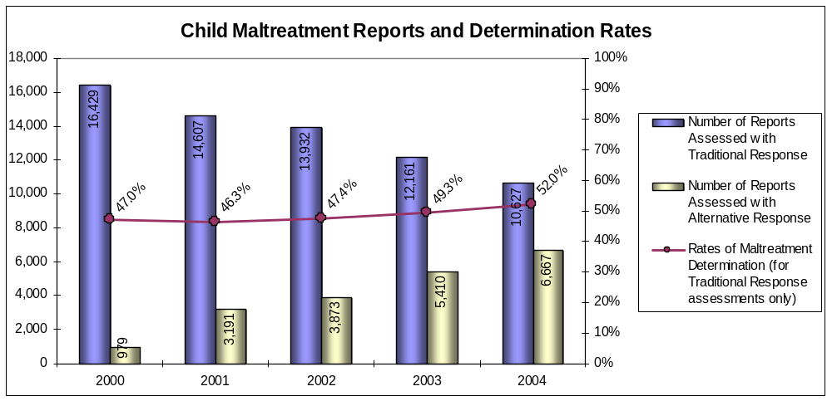

Graph 5-2 shows the types of determined maltreatment from 2000 to 2004. In each of the years, neglect accounted for the largest portion of the determinations, followed by physical abuse and then sexual abuse. A finding of neglect was made two to three times as often as a finding of physical abuse, and five to seven times as often as sexual abuse. The proportion of determinations that are neglect and sexual abuse are generally increasing, while the proportion of determinations that are physical abuse are generally decreasing.

Graph 5-2
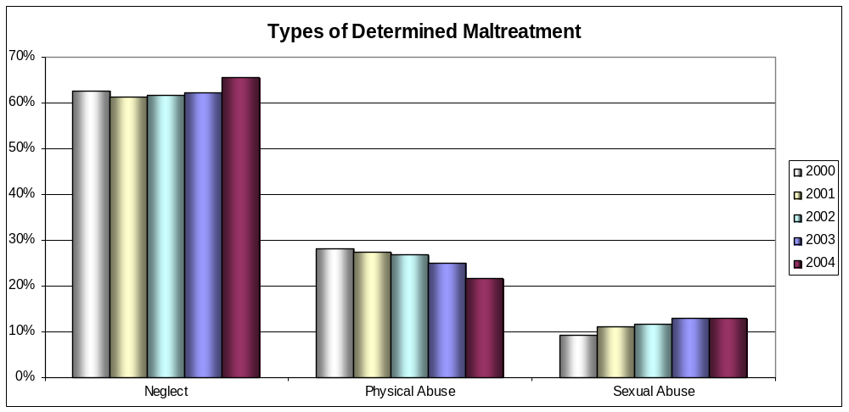

Graph 5-3 shows the severity of maltreatment for child victims from 2000 to 2004. The most common severity of determined maltreatment is “exposed to threatening or dangerous conditions” followed by “other,” “moderate injury,” and then “possible injury.” “Exposure to threatening or dangerous conditions” was 4 to 5.5 times more likely than moderate injury and 5 to 7 times more likely than “possible injury.” The proportion of determinations that involve “serious injury,” “exposed to threatening or dangerous conditions,” and “no discernible injury or impairment” are generally increasing. The proportion of determinations that involve “moderate injury,” “possible injury,” and “other” are generally decreasing.

Graph 5-3
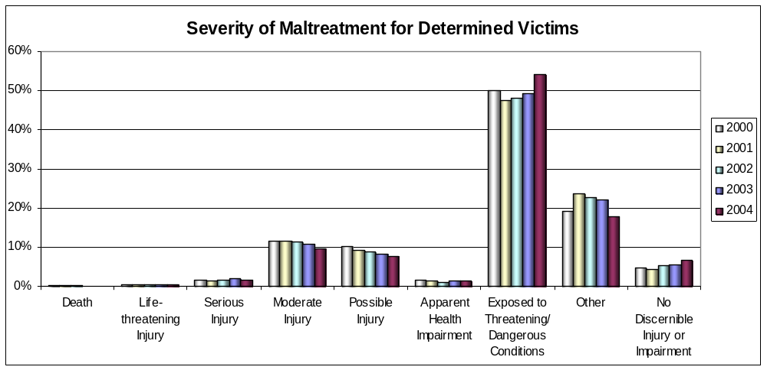

Graph 5-4 shows the age of maltreatment victims for 2004. The younger the child, the more likely it is that the child is a victim of determined maltreatment. Children under age 6 represent 43.5% of the victims; children ages 6 to 11 represent 33.5% of the victims; and children age 12 and older represent 23.0% of the victims.

Graph 5-4
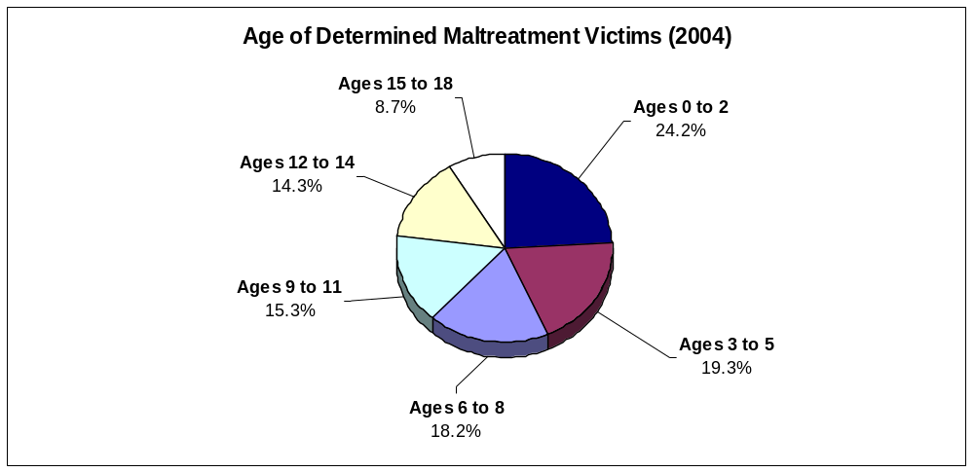

Graph 5-5 shows ratios of maltreatment determinations for 2000 to 2004 per 1,000 Minnesota population by race/ethnicity. The ratio of determinations per 1000 population for white children to African American/Black children is generally between 7 and 8, for American Indian children it is generally between 6 and 7.5, and for multiracial and Hispanic/Latino children the ratio is generally increasing.

Graph 5-5
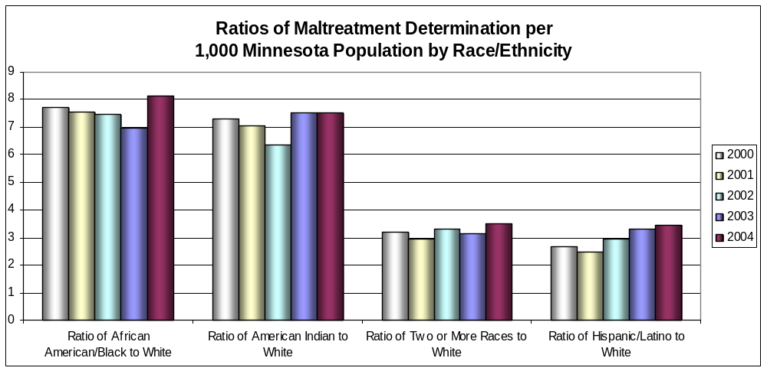
- CHIPS Petition

1. Update on Recommendations in 1997 Initial Assessment

All recommendations from the 1997 Initial Assessment regarding petitions have been implemented as follows:

- Recommendation: The Legislature should amend the statutes to provide that grounds for CHIPS exist where a child has been found incompetent to proceed or found to be not guilty by reason of mental illness or mental deficiency in a juvenile petty or traffic offender proceeding, delinquency proceeding, extended jurisdiction juvenile proceeding or certification proceeding.
  - Update: Minn. Stat. § 260C.007, subd. 6, was amended consistent with this recommendation.

- Recommendation: There should be a uniform, simplified process throughout the state for bringing a private Child In Need of Protection or Services (CHIPS) petition.
  - Update: Minn. Stat. § 260C.141, subd. 1(b), was amended consistent with this recommendation.

- Adjudication

1. Update on Recommendations in 1997 Initial Assessment

All recommendations from the 1997 Initial Assessment regarding adjudication have been implemented as follows:

- Recommendation: A child should not be required to admit a CHIPS petition in order for the matter to proceed to adjudication without trial except where the basis for the CHIPS allegation is the child’s act of omission or commission. The Minnesota Rules of Juvenile Procedure should be revised to clarify which parties in what circumstances must admit a CHIPS petition in order for the matter to proceed to adjudication without a trial.
    - Update: Rule 35 of the Rules of Juvenile Protection Procedure was amended consistent with this recommendation.

- Recommendation: Minnesota Statutes § 260.191, subd. 4, should be amended to limit the time a child may be continued without adjudication to just one period not to exceed ninety (90) days. The statute should also provide that, at the end of that period, if both the parents and child prove they have complied with the terms of the continuance, the case should be dismissed without an adjudication. Additionally, the statute should require that, if either the parents or the child have not complied with the terms of the continuance during that period, the court shall adjudicate the child.
    - Update: Minn. Stat. § 260C.201, subd. 12, was amended consistent with this recommendation.
2. Reassessment Findings

Juvenile Protection Rule 40.01 provides that if the court makes a finding that the statutory grounds set forth in a petition are proved, the court shall either (a) adjudicate the child as in need of protection or services and proceed to disposition; or (b) withhold adjudication of the child for up to 90 days. Adjudication should occur within 60 days of the Admit/Deny Hearing.

Among the core goals and standards measured as part of the CJI is Outcome Measure M10.7.1 – the “percent of cases that are adjudicated within 60 days of first hearing” and the accompanying indicator is the “average number of days between first hearing and adjudication.”

Graph 5-6 reflects that Minnesota has experienced mixed results over the past five years in the timely adjudication of child protection cases. There was steady improvement from 2000 to 2002 in the percent of cases adjudicated within 60 days of the filing of the petition, an increase from 58.6% to 62.9%. However, in 2003 and 2004 there was a reversal of that trend and the percent of cases adjudicated within 60 days of the filing of the petition dropped to 60.3%. Similarly, there was steady improvement from 2000 to 2003 in the average number of days between first hearing and adjudication, a decrease from 71.8 days to 64.1 days; but in 2004 that trend reversed and the average number of days between the first hearing and adjudication rose to 67.0 days. Despite the trends, these numbers are a dramatic improvement over the numbers contained in the 1997 Initial Assessment which reported an average of 85 days from first hearing to adjudication.

Graph 5-6
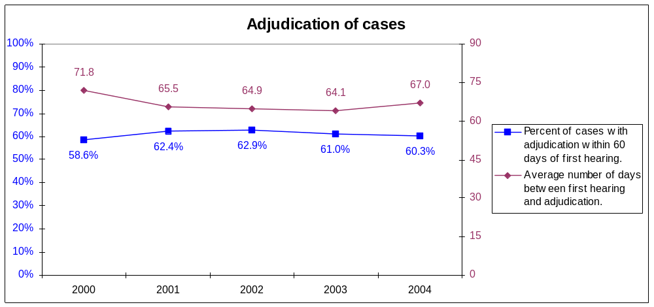

- Disposition and Out-of-Home Placement

1. Update on Recommendations in 1997 Initial Assessment

All recommendations from the 1997 Initial Assessment regarding disposition have been implemented as follows:

- Recommendation: The Legislature should amend Minnesota Statutes to add a subdivision which defines “best interests of the child” as follows:
“The ‘best interests of the child’ means all relevant factors to be considered and evaluated including, but not limited to, the following:
(1) the child’s current functioning and behaviors;
(2) the child’s medical, education and developmental needs;
(3) the child’s history and past experience;
(4) the child’s religious and cultural needs;
(5) the child’s connection with a community, school or church;
(6) the child’s interests and talents;
(7) the child’s relationship to current caretakers, parents, siblings and relatives; and
(8) the reasonable preference of the child, if the court deems the child to be of sufficient age to express preference.”
    - Update: Minn. Stat. § 260C.212, subd. 2, was amended consistent with this recommendation.

2. Reassessment Findings

Juvenile Protection Rule 41.01 provides that after a child has been adjudicated in need of protection or services, the court must conduct a hearing to determine the disposition. To the extent practicable, the court shall conduct the disposition hearing and enter a disposition order the same day it makes a finding that the statutory grounds set forth in the petition have been proved. The disposition order must be issued within ten 10 days of the date the court finds that the statutory grounds set forth in the petition have been proved.

For children adjudicated in need of protection or services, Minnesota’s statutes authorize a variety of dispositions regarding the child’s placement. The court may order that the child remain at home under the protective supervision of the social services agency, be placed in out-of-home placement in foster care or with a licensed relative, or a trial home visit if the child is removed from home.

Graphs 5-6 through 5-13 provide disposition data from 2000 to 2004 about the number of children in out-of-home care, including their age, race/ethnicity, reason for entering care, placement settings, number of moves while in care, and rate of re-entry into care within 12 months of a prior placement.

Graph 5-6 shows that in 2004 in Minnesota, 14,359 children were in out-of-home care and experienced 15,884 placements, for an average of 1.1 placements per child.

Graph 5-6
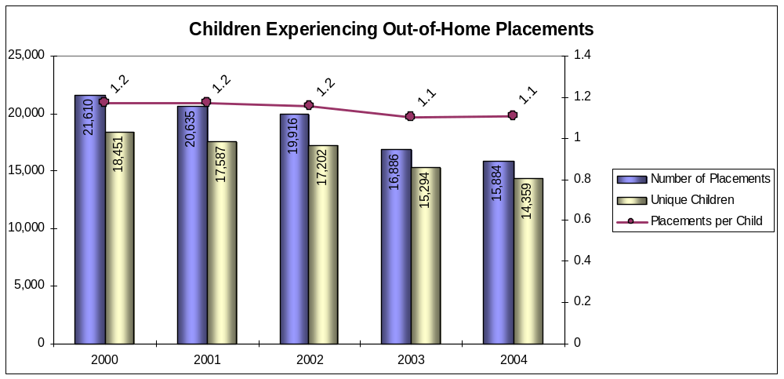

Graph 5-7 identifies the reasons children entered cared from 2000 to 2004. The most common reason was “child behavior,” followed by “alleged neglect” and “caretaker inability to cope.” The proportion of “child behavior,” “child disability,” “child drug use,” “alleged physical abuse,” and “child alcohol abuse” reasons are decreasing, while the proportion of “alleged neglect,” “alleged physical abuse,” and “parent drug abuse” reasons are increasing.

Graph 5-7
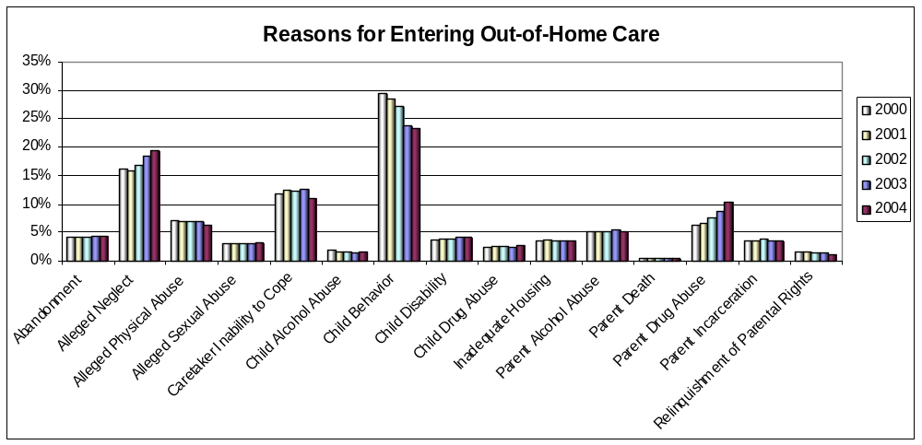

Graph 5-8 shows the age of children in out-of-home placement from 2000 to 2004. The largest proportion of children in out-of-home placement are age 15 and older, followed by 12- to 14-year-olds. Children age 12 and older are 2.5 to 3.5 times more likely to be in out-of-home placement than children age 5 and younger. The proportion of children in out-of-home placement age 2 years and younger and 3 to 5 years old is steadily increasing.

Graph 5-8
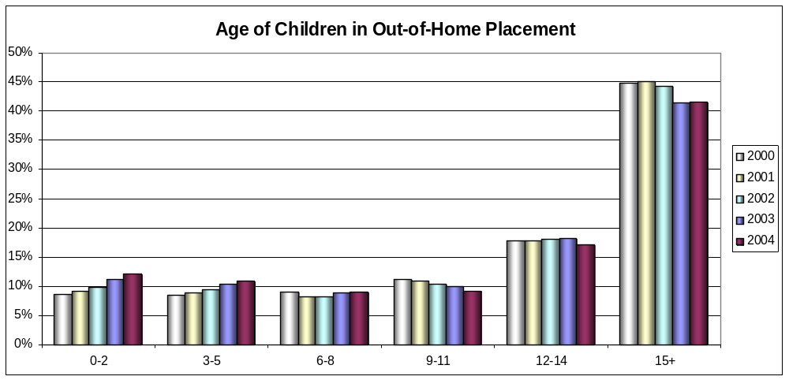

Graph 5-9 shows the types of out-of-home placements experienced by abused and neglected children from 2000 to 2004. The majority of children in out-of-home care are in a family setting. The proportion of children in out-of-home care in a family setting is generally increasing, while the proportion of children in residential treatment/institution and group home settings are generally decreasing.
Graph 5-9
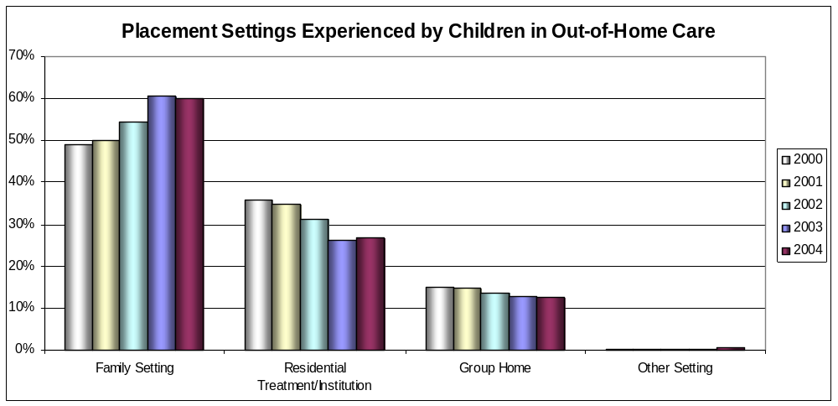
Graph 5-10 identifies the race/ethnicity of children in out-of-home placement from 2000 to 2004. The majority of children in out-of-home placement are White, followed by African American/Black, and then American Indian. There are 2.5 to 3 times as many White children in out-of-home placement as African American/Black children, and 4.5 to 5.5 times as many White children as American Indian children. However, the proportions of African American/Black, American Indian, and Hispanic/Latino children are generally increasing, while the proportions of White and multiracial children in care are generally decreasing.

Graph 5-10
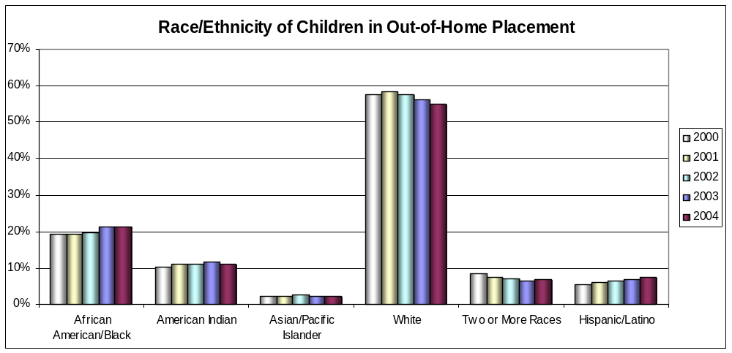

Graph 5-11shows the frequency of moves for children in out-of-home care from 2000 to 2004. The proportion of children experiencing no moves or one move is generally increasing, while proportion of children experiencing two or more moves is steadily decreasing.
Graph 5-11
Frequency of Moves Within a Placement for Children in Out-of-Home Care
0%
10%
20%
30%
40%
50%
60%
70%
No Moves
1 Move
2 or more Moves
2000
2001
2002
2003
2004
Graph 5-12 identifies the average length of out-of-home stay per placement from 2000 to 2004. Children in out-of-home care because of “child disability reasons” are in placement 2 to 3 times longer then children placed for “parent reasons” and 5.5 to 8 times longer than children place for “child reasons.” Children in out-of-home care because of “parent reasons” are in placement 2 to 4.5 times longer than children placed for “child reasons.” The length of time children spend in out-of-home care is generally increasing if they are placed because of “child reasons,” “child disability reasons,” or “two or more reasons.”

Graph 5-12
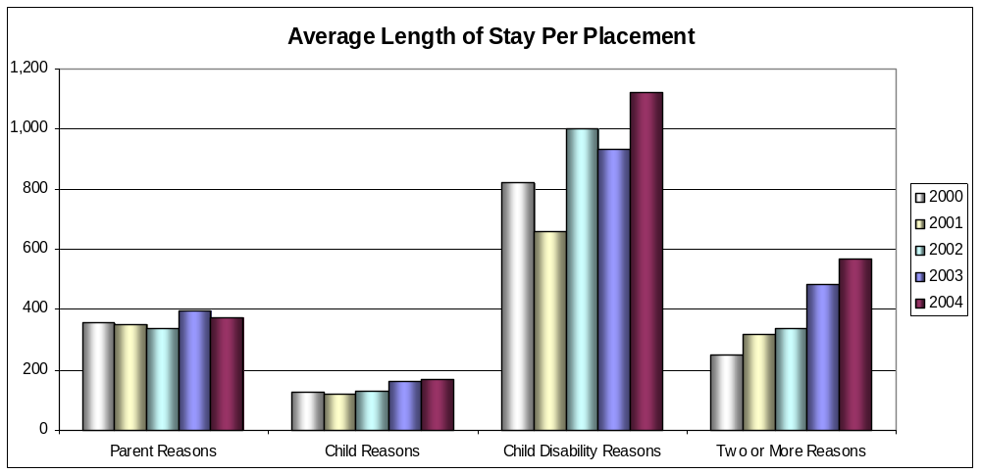

Graph 5-13 shows the rate of re-entry into foster care within 12 months of a prior placement from 2000 to 2004. Re-entry rates within 12 months of a prior placement are fairly equal. Re-entry rates for all racial/ethnic groups, except Asian/Pacific Islander, are decreasing.
Graph 5-13
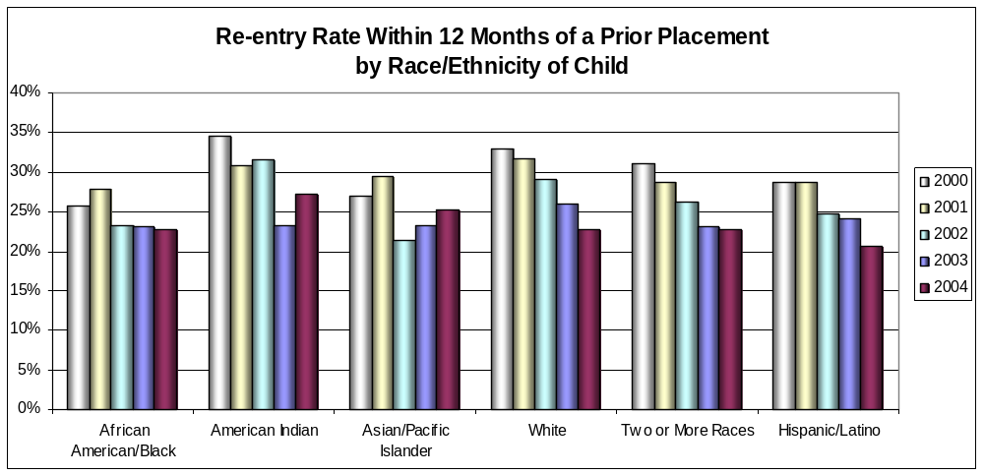
- Review of Disposition

Juvenile Protection Rule 4.106 requires that when disposition is an award of legal custody to the responsible social services agency, the court shall review the disposition in court at least every 90 days. Any party or the county attorney may request a review hearing before 90 days. When the disposition is protective supervision, the court must review the disposition in court at least every 6 months from the date of disposition.

CJI Performance Measure M12.1.1 is the “percent of cases with the first in-court hearing within 90 days of adjudication” and the accompanying indicator is the “average number of days between adjudication and first in-court hearing.” Graph 5-14 establishes that Minnesota has made excellent progress over the past five years in conducting timely disposition review hearings. There was steady improvement from 2000 to 2004 in the percent of cases with the first in-court hearing within 90 days of adjudication, an increase from 50.0% to 70.0%. Likewise, there was steady improvement in the average number of days between adjudication and the first in-court hearing, a decrease from 104.7 days to 70.1 days.

Graph 5-14
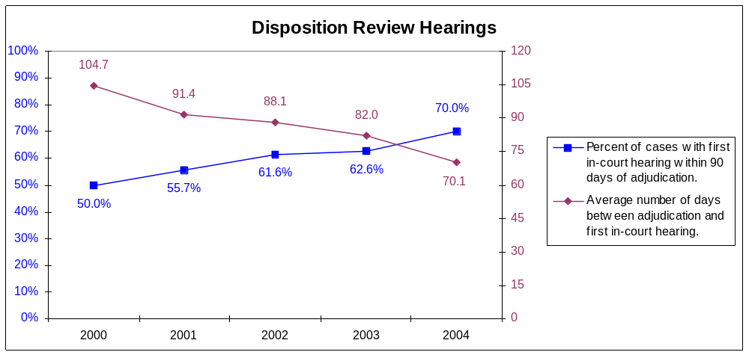

- Permanency

1. Update on Recommendations in 1997 Initial Assessment

Nearly every recommendation from the 1997 Initial Assessment regarding permanency has been implemented as follows:

- Recommendation: The Legislature should amend Minnesota Statutes to emphasize that the paramount consideration in all proceedings for the termination of parental rights is the best interests of the child by placing that statement at the beginning of the provision instead of near the end.
    - Update: While Minn. Stat. § 260C.001, subd. 3, was amended to establish the best interests standard as recommended above, the placement of that standard continues to be near the end of the statute.

- Recommendation: The Legislature should amend Minnesota Statutes to provide that the permanency time clock is started at the earlier of (1) the first court-ordered placement of the child or (2) the first court-approved placement of the child (where the child has been in voluntary placement for reasons other than developmental disability or emotional handicap).
    - Update: Minn. Stat. § 260C.201, subd. 11, was amended consistent with this recommendation.

- The Legislature should amend Minnesota Statutes to provide that the during the course of one CHIPS petition, the permanency time clock should not start over again when a child is placed in foster care after being returned home. The total time a child spends in foster care during one petition should be added together to determine when a permanent placement hearing must be held.
    - Update: Minn. Stat. § 260C.201, subd. 11(a), was amended consistent with this recommendation.

- The Legislature should amend Minnesota Statutes to provide that for subsequent CHIPS Petitions when the child has been placed out of the home in connection with a previous CHIPS petition or CHIPS petitions filed within the past five years, the time the child has been placed out of the home in connection with the existing CHIPS petition and all previous CHIPS petitions filed within five years of the present petition should be added together to determine the time for a permanency placement determination hearing.
    - Update: Minn. Stat. § 260C.201, subd. 11(a)(2), was amended consistent with this recommendation.

- Recommendation: The Legislature should amend Minnesota Statutes to provide that voluntary placements of children who are not developmentally disabled or emotionally handicapped are limited to ninety (90) days. Prior to the end of the ninety (90) days, the court may return the child home or approve the voluntary placement and extend the placement for another ninety (90) days. The parent, legal guardian or legal custodian and child have a right to counsel (at public expense, if necessary) at the hearing to approve and extend a voluntary placement. The court’s approval of the voluntary placement triggers the permanency time clock. During this second ninety (90) day period, the parent, legal guardian or legal custodian still have the right to remove the child from voluntary placement at any time. At the end of the second ninety (90) day period, the child must be returned home unless a CHIPS petition has been filed.
  - Update: Minn. Stat. § 260C.141, subd. 2, was amended consistent with this recommendation.

- Recommendation: The Legislature should revise Minnesota Statutes to require that, following the court’s approval of the voluntary placement of a developmentally disabled or emotionally handicapped child at the hearing to review foster care status, subsequent reviews shall occur every twelve (12) months during the continuation of foster care.
  - Update: Minn. Stat. § 260C.141, subd. 2(b), was amended consistent with this recommendation.

- Recommendation: The Legislature should revise Minnesota Statutes to provide that when a transfer of permanent legal and physical custody to a relative is recommended as a permanent placement, that transfer will occur as a juvenile court matter. Subsequent modifications of permanent legal and physical custody shall take place in family court. The Juvenile Rules Committee should revise the juvenile protection rules to provide for a procedure for the transfer of permanent legal and physical custody to a relative when that is the permanent placement plan.
  - Update: Minn. Stat. § 260C.141, subd. 2, was amended consistent with this recommendation.

- Recommendation: The Legislature should amend Minnesota Statutes to provide that when the county makes a permanent placement recommendation that permanent legal and physical custody be transferred to a relative, that relative shall be considered a party, shall have a right to notice of every hearing thereafter (including notice of the permanent placement determination hearing), and shall have the right to counsel appointed at public expense. Once the order has been entered, the relative does not have a right to counsel appointed at public expense in actions to modify the order. The Juvenile Protection Rules should also be amended.
  - Update: The statute was not amended; however, Juvenile Protection Rule 22.01, subd. 2, was amended to provide that the relative is a participant although not entitled to court appointed counsel at public expense.

- Recommendation: The Rules of Juvenile Procedure should be revised to provide that counsel for the child, counsel for the parent(s), the guardian ad litem, and counsel for the guardian ad litem should continue to represent their clients through the transfer of permanent legal and physical custody to a relative when that is the permanent placement.
  - Update: Juvenile Protection Rule 25.01 regarding legal counsel and Rule 26.03 regarding the guardian ad litem were amended consistent with this recommendation.

- Recommendation: The permanent placement disposition options for runaways, truants, and delinquents under age 10 should be expanded to include “foster care for a specified period of time” where (1) either truancy, running away or committing a delinquent act under age 10 was the sole basis for the CHIPS adjudication and (2) the court finds that “foster care for a specified period of time” is in the best interests of the child. The court shall review a permanent placement of “foster care for a specified period of time” every six (6) months.
  - Update: Minnesota Statutes § 260C.201, subd. 11(d)(4), was amended consistent with this recommendation.

- Recommendation: The Legislature should amend Minnesota Statutes to comply with the holding of In re the Welfare of S.Z., 547 N.W.2d 886 (Minn. 1996), which provides that, in some cases, any provision of services or further provision of services would be futile and therefore unreasonable. The Legislature should also amend Minnesota Statutes comply with the Child Abuse Prevention and Treatment Act Amendments of 1996 by providing that reunification of a surviving child with a parent is not required when that parent has been found by a court of competent jurisdiction:
(1) to have committed murder of another child of such parent;
(2) to have committed voluntary manslaughter of another child of such parent;
(3) to have aided or abetted, attempted, conspired, or solicited to commit such murder or voluntary manslaughter; or
(4) to have committed a felony assault that results in the serious bodily injury to the surviving child or another child of such parent.
  - Update: Minnesota Statutes § 260C.178, subd. 1(e)(3), was amended consistent with this recommendation.

- Recommendation: The Legislature should amend Minnesota Statutes to expand the definition of “egregious harm” as a ground for termination of parental rights so that it includes the crimes and circumstances listed below when the parent has been found by a court of competent jurisdiction:
  - to have committed murder of another child of such parent;
  - to have committed voluntary manslaughter of another child of such parent;
  - to have aided or abetted, attempted, conspired, or solicited to commit such murder or voluntary manslaughter; or
  - to have committed a felony assault that results in the serious bodily injury to the surviving child or another child of such parent.
  - Update: Minnesota Statutes § 260C.007, subd. 14, was amended consistent with this recommendation.

2. Reassessment Findings

The Adoption Assistance and Child Welfare Act of 1980 (“P.L. 96-272”) was enacted to curb unnecessary removal of children from their homes and to remedy the problem of children trapped in “foster care drift.” P.L. 96-272 conditions a state’s receipt of federal funding for foster care on the state’s compliance with federal provisions and requires each state to develop a plan as to how compliance will be achieved. The law emphasizes preventive and reunification services and permanency planning for children by requiring, among other things, that:
- reasonable efforts be made to eliminate the need to remove a child from home and, once the child is removed, that reasonable efforts be made to return the child home;
- each child [in placement] has a case plan;
- the status of the child be reviewed every 6 months;
- each child remain in placement no more than 18 months after the original placement before a “dispositional hearing is held to . . . determine the future status of the child”; and
- a “dispositional hearing to . . . determine the future status of the child” is held not less frequently than every 12 months thereafter during the continuation of foster care.

P.L. 96-272 also gives juvenile court judges oversight responsibility of children in placement by requiring the judges to: (1) make reasonable efforts determinations and (2) conduct permanent placement determination hearings.

In 1993, Minnesota enacted legislation which set forth a more aggressive timeline than that provided by federal law for scheduling a dispositional hearing to determine the future status of the child The statute currently provides that if the court places a child in a foster care, the court shall conduct a hearing to determine the permanent status of the child (a permanent placement determination hearing or “PPD hearing”) not later than 12 months after the child was placed out of the home of the parent. The court may extend the time period for determination of permanent placement to 18 months after the child was placed in a residential facility if:
- there is a substantial probability that the child will be returned home within the next six months;
- the agency has not made reasonable, or, in the case of an Indian child, active efforts, to correct the conditions that form the basis of the out-of-home placement; or
- extraordinary circumstances exist precluding a permanent placement determination, in which case the court shall make written findings documenting the extraordinary circumstances and order one subsequent review after six months to determine permanent placement. A court finding that extraordinary circumstances exist precluding a permanent placement determination must be supported by detailed factual findings regarding those circumstances. If a petition to terminate parental rights is filed before the date for the PPD hearing, the PPD hearing does not need to be held.

CJI Outcome Measure M4.1.1 is the “percent of children under 8 with out-of-home placement over 365 days” and the accompanying indicator is the “Average length of out-of-home placement for children under 8.” CJI Outcome Measure M4.2.1 is the “percent of all children with out-of-home placement over 365 days” and the accompanying indicator is the “Average length of out-of-home placement for all children.”

Minnesota has made excellent progress over the past five years in reducing the amount of time children spend in out-of-home placement. Graph 5-15 shows that, with the exception of 2001, there was steady improvement from 2000 to 2004 in the percent of children who were in out-of-home placement longer than 365 days at the permanent placement determination hearing: for children under 8, the percentage dropped from 32.2% to 21.1%; and for all children, the percentage dropped from 35.4% to 27.0%.

Similarly, Graph 5-16 shows there was fairly steady improvement from 2000 to 2004 in decreasing the average number of days children spent in out-of-home placement before a permanent placement determination: for children under 8, the average dropped from 303.2 days to 246.5 days, and for all children, the average dropped from 321.4 days to 280.4 days.

These improvements are even more dramatic when compared to the statistics contained in the 1997 Initial Assessment which reported that 67% of children were in out-of-home placement over 365 days for an average time of 468.4 days.

Graph 5-15
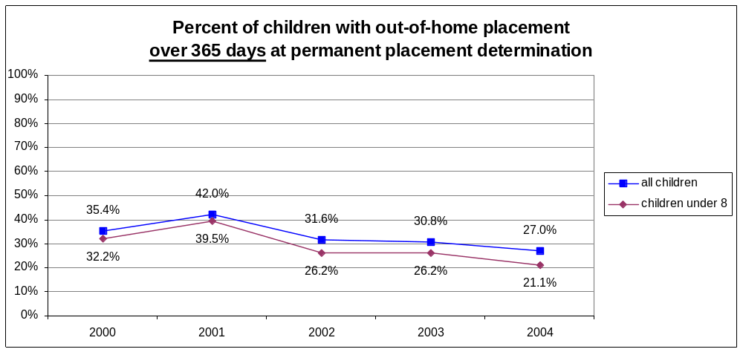
Graph 5-16
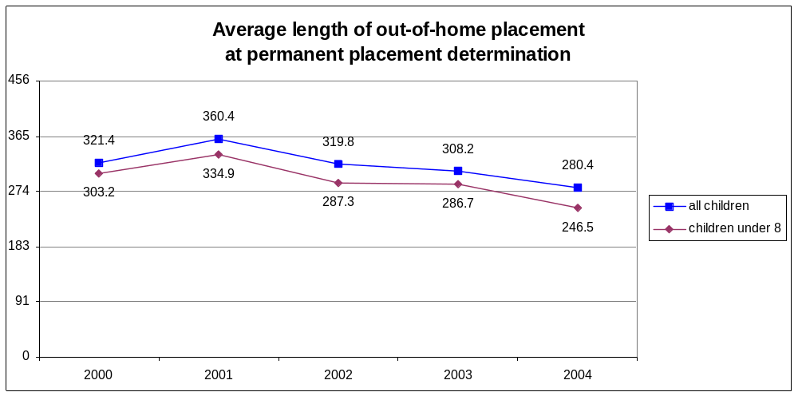

- Adoptions

1. Update on Recommendations in 1997 Initial Assessment

Nearly every recommendation from the 1997 Initial Assessment regarding adoptions has been implemented as follows:

- Recommendation: There should be continuing court jurisdiction following TPR. Where TPR has occurred and adoption is the plan, the guardian ad litem and attorney for the child shall continue on the case until the adoption is finalized. Following TPR, in-court review hearings shall be held every three (3) months to determine what progress has been made toward adoption. Where long term foster care is the permanent placement, the guardian ad litem and attorney for the child should be dismissed on the effective date of the permanent placement order. The child, if of sufficient age, and the foster parents should be given information on how to contact the guardian ad litem program or a guardian ad litem. If the matter is returned to court, a guardian ad litem should be reappointed.
    - Update: Minnesota Statutes § 260C.178, subd. 1(e)(3), was amended consistent with this recommendation.

- Recommendation: The Rules of Appellate Procedure and the Rules of Juvenile Procedure should be amended to provide that the Court of Appeals has jurisdiction to decide any challenges that arise in pending proceedings in which an adoptive petition, adoptive placement or both are challenged, or any proceeding challenging a final adoption decree.
    - Update: The Court Rules have not been updated consistent with this recommendation; however, the rules do not preclude the Court of Appeals from asserting jurisdiction.

- Recommendation: The Rules should also be amended to provide that the Court of Appeals shall decide these challenges within ninety (90) days, with one thirty (30) day extension allowed.
    - Update: Rule 40 of the Adoption Rules was amended to provide that the Court has 60 days (rather than 90 days) to issue its opinion in adoption matters.

- Recommendation: The Rules of Appellate Procedure and the Rules of Juvenile Procedure should be amended to provide expedited deadlines for the filing of an appeal, submission of briefs, oral argument, and issuance of an opinion in any appeal pertaining to a contested adoptive petition, adoptive placement or final decree of adoption.
    - Update: Rule 40 of the Adoption Rules was amended to expedite appeals in adoption matters, though not specifically as recommended above. Additional research is being conducted regarding how to further expedite appeals.

- Recommendation: Minnesota Statutes § 259.21 should be amended to include a provision defining “putative father” as “any man who may be a child's father, but who (1) is not married to the child's mother on or before the date that the child was or is to be born and (2) has not established paternity of the child in a court proceeding before the filing of a petition for the adoption of the child. The term includes a male who is less than 18 years of age.”
    - Update: Minnesota Statutes § 259.021, subd. 12, was amended consistent with this recommendation.

- Recommendation: The list of those entitled to receive notice of an adoption hearing pursuant to Minnesota Statutes § 259.49 (and to consent to the adoption pursuant to Minnesota Statutes § 259.24) should be expanded to include the parent of a child if:
- The person has filed a paternity action within sixty (60) days after the child’s birth and the action is still pending; or
- The person and the mother of the child have signed a declaration of parentage pursuant to Minnesota Statutes § 257.34 before August 1, 1995 which has not been revoked or a recognition of parentage pursuant to Minnesota Statutes § 257.75 which has not been revoked; or
- the person has complied with the requirements of the Putative Father Registry entitling that person to notice of the adoption hearing.
- Update: Minnesota Statutes § 259.49 was amended consistent with this recommendation.

- Recommendation: The Legislature should replace Minnesota Statutes § 259.51 (the “60 / 90 Day Statute”) with a Putative Father Registry.
  - Update: Minnesota Statutes § 259.52 was amended consistent with this recommendation.

2. Reassessment Findings

Pursuant to Minnesota Statutes § 260C.201, subd. 11, termination of parental rights leading to adoption is one of the permanency options available to courts regarding children who remain in out-of-home placement at month 12.

Graph 5-17 shows the time from Termination of Parental Rights (TPR) to adoption for children whose parents’ rights were terminated (“state wards”) during 2000 to 2004. The vast majority of children were adopted within two years of the TPR decision. The proportion of children who were adopted within one year is steadily increasing, while the proportion of children who are adopted more than two years after the TPR is generally decreasing.

Graph 5-17
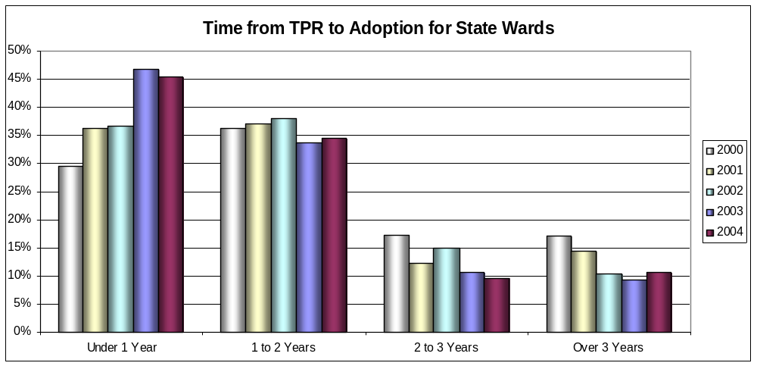

Graph 5-18 shows that in 2004, 555 children whose parents’ rights were terminated (“state wards”) were adopted, and 740 children became state wards.

Graph 5-18
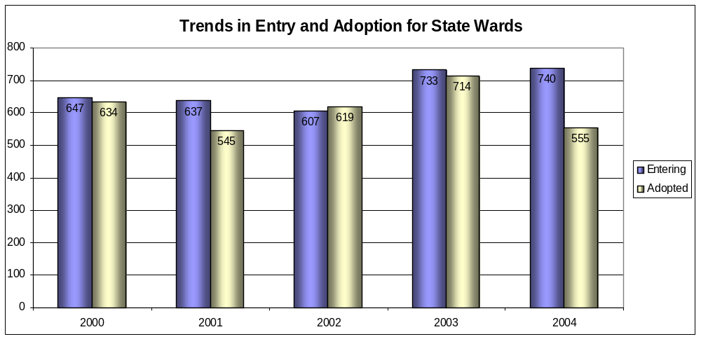

Graph 5-19 shows that children 11 years old and younger comprised a majority (56.2%) of state wards at the end of 2004.

Graph 5-19
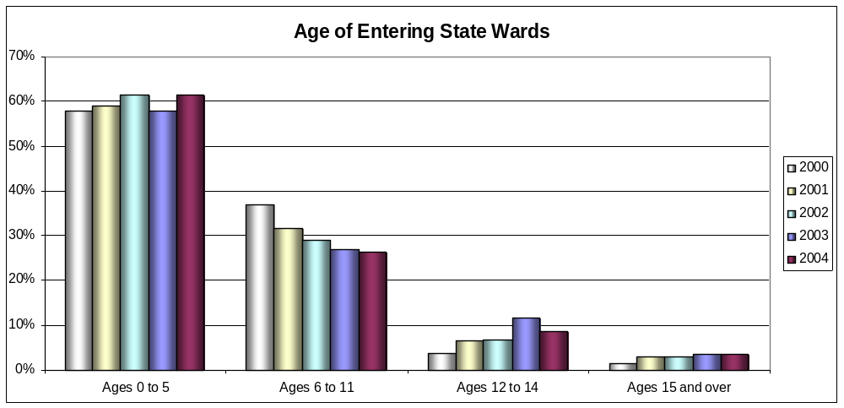

Graph 5-20 shows that children of color comprised a majority (52.1%) of state wards at the end of 2004.

Graph 5-20
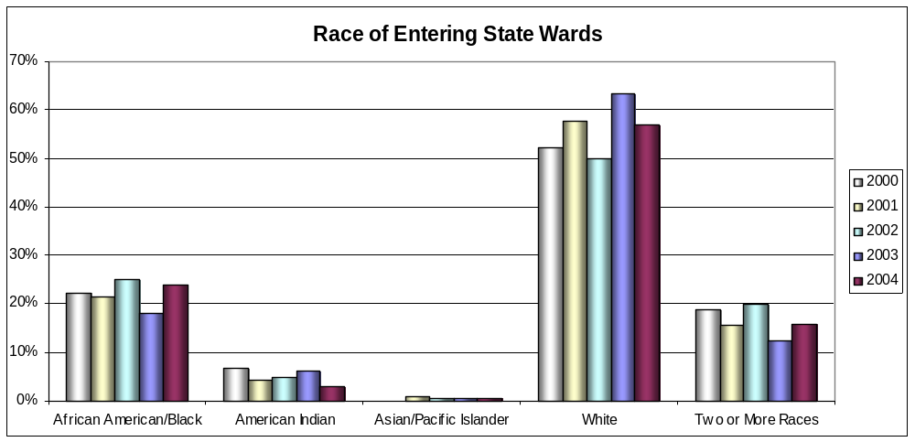

A. Funding Streams

The findings in the Initial Assessment show that in 1995 over $300 million dollars were spent on child welfare services in Minnesota (excluding children's mental health services). Over half of these expenditures ($160.8 million) were for out of home placements for children who were removed from their families. By contrast, in 2003 (the most recent year for which data was obtained), over $484 million was spent on child welfare services in Minnesota (excluding children’s mental health services). Expenditures for out-of-home placements for children removed from their families amounted to over $150 million in 2003.

Child welfare funds are provided by federal, state, and county levels of government. The single largest source of funding is the county social service property tax levy. In calendar year 1995 this amounted to over $171 million statewide. Two block grant programs, the state's Community Social Service Act (CSSA) grant and the federal Title XX block grants are awarded annually to support all county social services, not just child welfare. It is estimated that the counties spend about half of these funds on child welfare programs: $25.8 million CSSA funds and $17.5 million Title XX funds in 1995. In calendar year 2003 the block grant amounted to over $180 million statewide. Each county has substantial discretion on how the social service property tax levy dollars and the block grant funds will be spent. The $300.8 million dollars spent on child welfare services can be broken down as follows:

Source of Funding | Amount 1995  (in millions) | Amount 2004  (in millions)
County Property Tax | $ 171.2 | $180.5
Social Service Block Grants | $ 43.3 | $ 39.1
Title IV-E Foster Care and Administration | $ 29.8 | $ 93.3
Child Welfare Targeted Case Management Services | $ 12.7 | $ 44.8
Family Preservation Funds | $ 10.3 | $ 32.3
Emergency Assistance Intensive Family Preservation Services | $ 8.6 | ------
Other Grants | $ 24.9 | $ 94.4
TOTAL CHILD WELFARE | $ 300.8 | $484.4

B. Representation of Children and Parents

1. Appointment of Guardian ad Litem and/or Legal Counsel for Child

Minnesota Statutes § 260C.163, subd. 5, requires the appointment of a guardian ad litem in every court matter alleging a child’s need for protection or services. Minnesota Statutes § 260C.163, subd. 3, provides that except in proceedings where the sole basis for the petition is habitual truancy, if the child, parent, guardian, or custodian desires counsel but is unable to employ it, the court shall appoint counsel to represent the child who is ten years of age or older or the parents or guardian in any case in which it feels that such an appointment is appropriate. In any proceeding where the sole basis for the petition is habitual truancy, the child, parent, guardian, and custodian do not have the right to appointment of a public defender or other counsel at public expense. However, before any out-of-home placement, including foster care or inpatient treatment, can be ordered, the court must appoint a public defender or other counsel at public expense as noted above.

CJI Outcome Measure M10.3.1 is the “percent of children assigned a guardian ad litem.” Minnesota has made excellent progress over the past five years in making sure that children involved in child protection matters are assigned a guardian ad litem. Graph 6-1 establishes that there was steady improvement from 2000 to 2004 in the percent of children assigned a GAL, increasing from 70.5% to 94.6%. As of 2005, the rate is nearly 99%. These improvements are even more dramatic when compared to the statistics contained in the 1997 Initial Assessment which reported only 54% of children were assigned a guardian ad litem.

CJI Outcome Measure M11.1.1 is the “percent of all children represented by counsel” and Outcome Measure M11.1.2 is the “percent of children 10 and over represented by counsel.” Graph 6-1 shows that Minnesota has seen a steady decline over the past five years in the percent of children represented by counsel. For children who are 10 or older, the percentage dropped from 62.1% in 2000 to 50.7% in 2004; for all children, the percentage dropped from 39.3% to 25.9% over the same time period. In the 1997 Initial Assessment, it was found that 44% of all children were represented by counsel.

Graph 6-1
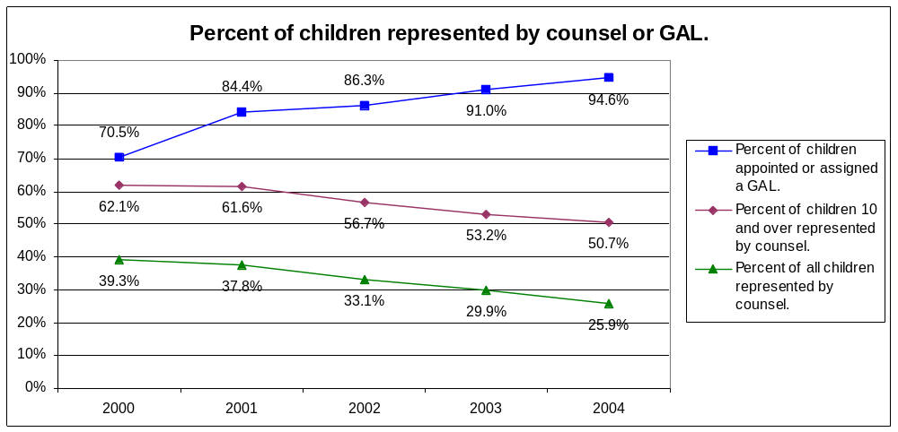

2. Appointment of Counsel for Parent or Legal Custodian

Minnesota Statutes § 260C.163, subd. 3, provides that except in proceedings where the sole basis for the petition is habitual truancy, if the child, parent, guardian, or custodian desires counsel but is unable to employ it, the court shall appoint counsel to represent the child who is ten years of age or older or the parents or guardian in any case in which it feels that such an appointment is appropriate. In any proceeding where the sole basis for the petition is habitual truancy, the child, parent, guardian, and custodian do not have the right to appointment of a public defender or other counsel at public expense. However, before any out-of-home placement, including foster care or inpatient treatment, can be ordered, the court must appoint a public defender or other counsel at public expense as noted above.

CJI Outcome Measure M11.4.1 is the “percent of cases in which all parents are represented by counsel” and Outcome Measure M11.4.2 is the “Percent of cases in which any parent is represented by counsel.” Graph 6-2 establishes that Minnesota has seen mixed results over the past five years in the percent of parents represented by counsel. There was fairly steady improvement from 2000 to 2004 in the percent of cases in which any parent had counsel, increasing from 63.6% to 71.7%. However, the percent of cases in which all parents had counsel remained fairly stable from 2000 to 2004, only fluctuating between 41.4% and 43.6%.

Graph 6-2
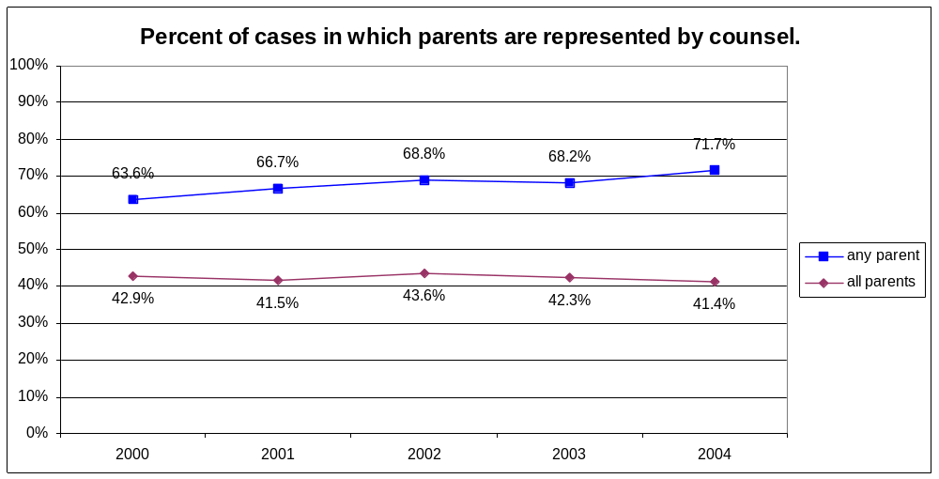

C. Publically Accessible Hearings and Records

While the Foster Care Task Force recognized the “controversial” nature of publicly accessible juvenile protection hearings, in the 1997 Initial Assessment it nevertheless was recommended that hearings involving child in need of protection or services (CHIPS) matters and termination of parental rights (TPR) matters should be presumed open to the public in the same manner as criminal proceedings are accessible to the public. Specifically, it was recommended that “[t]there should be a presumption that hearings in juvenile protection matters will be open absent exceptional circumstances.” It was also recommended that, with the exception of certain information, juvenile protection court files should be accessible to the public.

Following the Conference of Chief Judges’ approval of an Open Hearings/Records Pilot Project, on January 22, 1998, the Minnesota Supreme Court filed an “Order Establishing Pilot Project on Open Hearings in Juvenile Protection Matters”. Based upon its “inherent power and statutory authority” to “regulate public access to records and proceedings of the judicial branch,” the Court authorized the chief judge of each judicial district to designate one or more counties to participate in a pilot project in which hearings in juvenile protection proceedings “shall be presumed open and may be closed or partially closed by the presiding judge only in exceptional circumstances.” The Court specifically directed that “child in need of protection or services proceedings” be accessible to the public, as well as “permanent placement proceedings, termination of parental rights proceedings, and subsequent state ward reviews.” The court directed that the project begin June 1, 1998, and continue for three years. The pilot project was later extended through December 31, 2001, to allow time for a public hearing regarding the evaluation of the pilot project without disruption of the pilot project.

At the conclusion of a three-year evaluation of the pilot project, the National Center for State Courts submitted to the Supreme Court an report summarizing its findings. Following a public hearing regarding the evaluations findings and conclusions, the Supreme Court issued an order making child protection hearings accessible to the public statewide effective July 1, 2002. Likewise, child protection court files (with some exceptions) were made accessible to the public. In 2001, the Juvenile Protection Rules were amended to include provisions regarding publically accessible hearings and records.

Since implementation of Minnesota’s rules regarding open hearings and records, the federal Child Abuse Prevention and Treatment Act (CAPTA) has been amended to allow states to decide whether or not to allow open hearings and/or records.

D. Continuity and Case Management

In the 1997 Initial Assessment it was recommended that the district courts should implement case management systems to avoid the shifting of cases and families between judges. Specifically, it was recommended that CHIPS cases should be blocked so that one judge will hear the case throughout the proceedings up to and including the implementation of a permanent placement plan and adoption, if that occurs.

CJI Outcome Measure M7.1.1 is the “percent of cases with three or more judges” and the accompanying indicators are the “percent of cases with one judge” and the “average number of judges per case.” Graph 6-3 demonstrates that, after four years of no progress or decline, in 2004 Minnesota finally saw improvement in the number of judges that handle a case. The percent of cases with three or more judges rose slightly from 2000 to 2003, but dropped to 26.3% in 2004. Likewise, the average number of judges per case was 2.3 from 2001 to 2003, but dropped to 2.1 in 2004. The percent of cases with one judge steadily declined from 2000 to 2003, but in 2004 the percentage dramatically increased to 44.4%.

Graph 6-3
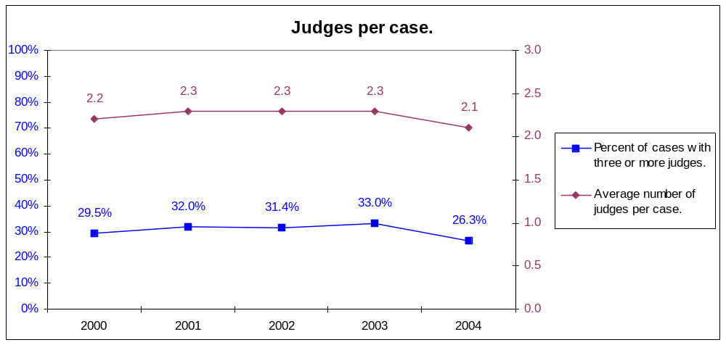
A. Children and Family Services Review

1. Overview of CFSR Process

Minnesota was the fourth State to participate in a Child and Family Services Review (CFSR). The CFSR is a process in which the Administration for Children and Families (ACF), in partnership with States, monitors and evaluates child and family services, including child protective services, family preservation and support, foster care, independent living and adoption services.

The first phase of the CFSR consisted of the development of a State Profile, derived from data for Federal Fiscal Year (FFY) 1999 contained in the Adoption and Foster Care Analysis and Reporting System (AFCARS) and for Calendar Year 1999 from the National Child Abuse and Neglect Data System (NCANDS). The profile highlighted key performance indicators related to safety and permanency for children entering the child welfare system. From this profile and other sources of information, Minnesota developed a Statewide Assessment (SWA), which described the process, procedures and policies of its child protective services, including foster care and adoption. This SWA also focused on the systemic factors in place which enable the State to carry out the program.

The second phase involved an on-site review, conducted in three counties and in St. Paul May 14 through 18, 2001. The purpose of the on-site review was to assess the quality of services to abused or neglected children and to verify the information contained in the State Profile and SWA. This was accomplished by an intensive examination of 49 cases, drawn at random, of children who were active in the system during the period under review (April 1, 2000 through May 13, 2001).

Individual and group interviews were also held in the four sites with more than 100 selected stakeholders who had the knowledge and experience to describe and assess the child and family services system. They included foster parents, judges, district attorneys, defense attorneys, caseworkers and their supervisors, guardians ad litem, police, and advocacy group representatives. The primary purpose of these interviews was to assess independently the quality and efficacy of the systemic factors described in the SWA.

The results of the SWA, the on-site case reviews, and the stakeholder interviews were compiled by the review team into this report and were used to make a determination about Minnesota’s substantial conformity with regard to each of seven outcomes related to safety, permanency and well-being, and each of seven systemic factors.

Substantial conformity is based upon the State’s ability to meet national standards; the criteria related to outcomes for children and families; and the criteria related to the State agency’s capacity to deliver services leading to improved outcomes. Ninety percent of the cases must be rated as “substantially achieved” during a State’s initial review for the State to be in substantial conformity for the outcomes.

2. Key Findings Relating to Safety, Permanency, and Well-Being

a. Safety Outcome 1: Children are, first and foremost, protected from abuse and neglect

Although Minnesota met the national standards for repeat maltreatment and maltreatment of children in foster care, only 87.23% of the cases reviewed were rated as substantially achieved. Thus this was an area denoted as needing improvement.

Strengths
- In most instances, face-to-face contacts on investigations were done within the established timeframes.
- During the review period, there were no instances of maltreatment of the foster care children whose cases were reviewed.

Areas Needing Improvement – A Program Improvement Plan was Implemented and Completed
- In some instances when abuse and neglect reports were given low priority, several days elapsed between the time the supervisor assigned the case and the investigator made the initial contact.
- Many reports were screened out or not investigated and there was no documentation regarding the reason.
- Many cases had extensive histories of repeat maltreatment prior to the review period.

b. Safety Outcome 2: Children are safely maintained in their homes whenever possible and appropriate

88.37% of the cases reviewed were rated as substantially achieved. Thus this was an area denoted as needing improvement.

Strengths
- Alternative response is a strength-based and community oriented approach to addressing child maltreatment reports that do not meet statutory requirements for a mandated investigative approach. Reports that do not meet the endangerment standard may be addressed with family assessment and services. Stakeholders and county personnel praised this approach in dealing with families.
- Some cases had intensive services such as anger management, in-home visits by public health nurses, prevention programs, integrated services and child care.

Areas Needing Improvement – A Program Improvement Plan was Implemented and Completed
- In some cases there was a lack of assessment of risk and identification of needs and in some cases services were provided but risk was not targeted.
- Some children were returned home with only time-limited monitoring and follow-up.

c. Permanency Outcome 1: Children will have permanency and stability in their living situation

Although Minnesota met the national standard on the length of time to achieve reunification, it did not meet the national standards on foster care re-entries, length of time to achieve adoption, and stability of foster care placements. In addition, only 62.50% of the cases reviewed were rated as substantially achieved. Thus this was an area denoted as needing improvement.

Strengths:
- There were examples of stable long-term foster care relative placements.
- There were many supportive services provided at the treatment foster care level.
- Due in part to tightened permanency timeframes for children under age eight, there were examples of successful reunifications in short periods of time.
- In recent years there have been significant increases in the number of children adopted.

Areas Needing Improvement – A Program Improvement Plan was Implemented and Completed
- In one county, half of the foster care cases had a history of multiple foster care re-entries prior to the period under review.
- The common practice of limiting respite care for foster care parents to 14 days resulted, in one instance, in an unnecessary placement change for a child.
- The usual practice of initially sending children to emergency shelters and temporary homes has a negative impact on stability.
- Appropriate concurrent planning occurred in some instances. Often other permanency options were often considered only when the original plan was abandoned.
- The differential rate between foster care and adoption assistance has the effect of discouraging adoptions.

d. Permanency Outcome 2: The continuity of family relationships and connections will be preserved for children

83.33% of the cases reviewed were rated as substantially achieved. Thus this was an area denoted as needing improvement.

Strengths
- Counties were mostly successful in placing children in the county of residence. Out-of-county placements generally occurred when children had special treatment needs or when their relatives or siblings were living in other counties. If out-of-county placements occurred because of treatment needs, efforts were made to bring the children back to the community as soon as possible.
- Caseworkers in areas near Indian reservations were respectful of tribal traditions that encourage parents to have continuing relationships with their children even after the termination of parental rights.
- Attempts were made to place siblings together. Separation of siblings was usually due to the needs of one or more of the children.
- Good efforts were made to locate both paternal and maternal relatives and assess their willingness to serve as foster or adoptive families.

Areas Needing Improvement – A Program Improvement Plan was Implemented and Completed
- In instances where siblings were separated, there were not always reassessments of whether they could be reunited.
- The lower level of financial support available under the Relative Custody Assistance program reduces the number of relatives who might take advantage of the program instead of remaining as foster parents.

e. Well-Being Outcome 1: Families will have enhanced capacity to provide for their children’s needs

71.43% of the cases reviewed were rated as substantially achieved. Thus this was an area denoted as needing improvement.

Strengths
- In counties where the alternative response system is well established, services and resources were matched to families’ needs.
- Generally, an exceptional array of services was available. There were individualized services and consideration of the identified service needs of children, parents, and foster parents.

Areas Needing Improvement – A Program Improvement Plan was Implemented and Completed
- Cases with unmet needs were almost always the result of a lack of proper assessment when the case was opened.
- Families of color who live away from high concentrations of other families of color are less likely to have access to culturally appropriate services within a reasonable distance.
- There did not appear to be clear guidelines as to who was responsible for what activity when multiple staff such as local service providers, probation officers, county caseworkers and Indian Tribal Organization social workers were involved.

f. Well-Being Outcome 2: Children receive appropriate services to meet their educational needs
81.58% of the cases reviewed were rated as substantially achieved. Thus this was an area denoted as needing improvement.

Strengths
- Foster parents received support and guidance regarding the Individual Education Plan.
- Developmental screenings for young children were taking place.
- Agency staff provided excellent advocacy for children with developmental delays.

Areas Needing Improvement – A Program Improvement Plan was Implemented and Completed
- There was too much reliance on foster parents to see to children’s educational needs.
- There were multiple school changes related to placement changes.
- The inclusion of school records in case records was the exception.
g. Well-Being Outcome 3: Children receive adequate services to meet their physical and mental health needs

67.39% of the cases reviewed were rated as substantially achieved. Thus this was an area denoted as needing improvement.

Strengths
- Timeframes for physical exams for entry into foster care were met.

Areas Needing Improvement – A Program Improvement Plan was Implemented and Completed
- There was too much reliance on foster parents to address health needs of children.
- It is very difficult to find adequate dental care for children in foster care because many providers do not participate in the Medicaid program.
- If a mental health issue was not directly related to the presenting problem, typically it was not addressed.

3. Key Findings For Seven Systemic Factors

a. Statewide Information System

In 1999, the Minnesota Dept. of Human Services implemented a Statewide Automated Child Welfare Information System (SACWIS) that can produce the information required by regulation, namely, the status, demographic characteristics, location and goals of every child who is (or within the immediately preceding 12 months, has been) in foster care. Minnesota achieved substantial conformity with respect to this factor.

b. Case Review System

Minnesota achieved substantial conformity with respect to this factor.

Strengths
- Court hearings and administrative reviews were held at required intervals.
- In some courts, the same judge was responsible for a case from its beginning until reunification or termination of parental rights.
- Public defenders, county attorneys, and guardians ad litem were experienced and typically stayed with a child’s case for its duration.
- Although the State’s more rigorous time frames for permanency hearings were not always met, the Federal time frames were met.
- Although there were instances of foster parents and representatives of Indian Tribal Organizations not having adequate notice of hearings, the State has a good system in place where either the social services agency or the court notifies all involved parties of court hearings.

Areas Needing Improvement
- Although all cases reviewed contained written case plans, some had not been updated for as long as three years and some case plans were general, ambiguous, and lacked specificity and individualization for services.
- Although guardians ad litem provided advocacy and oversight; their caseloads were very high.

c. Quality Assurance System

Minnesota achieved substantial conformity with respect to this factor.

Strengths
- Counties adhered to licensing standards. In the event that an exception was made for an emergency placement, the exception did not compromise safety.
- The State’s external review system, begun in 1998 and so far conducted in 37 counties, has had a positive effect on practice. Counties have made many changes based upon recommendations of the reviews.

Area Needing Improvement
- There is not a consistent, mandatory, county quality assurance review system in place.

d. Training

Minnesota achieved substantial conformity with respect to this factor.

Strengths
- Minnesota’s competency-based staff development and training, provided through the Minnesota Child Welfare Training System (MCWTS) by the University of Minnesota, offers high quality core and advanced training.
- In a county-administered system such as Minnesota’s, counties have considerable autonomy. One way the State promotes consistency is through training. Training on cultural competence helps child welfare staff meet the multiple and diverse needs of families. It may influence the way counties respond initially to children of color, whether they provide placement prevention services, and how they plan reunification.
- Foster parents indicated that, although there were exceptions, the quality of training for foster parents was excellent.

Area Needing Improvement
- Follow-up training was not always built into the training structure and comprehensive training on the Indian Child Welfare Act was not mandatory.
- Cross-cultural training for foster and adoptive parents that insures that children’s cultural needs related to customs, grooming, dietary needs, and religious practices was not always available.

e. Service Array

Minnesota achieved substantial conformity with respect to this factor.

Strengths
- Many services were targeted to African, African-American, Indian, Hispanic, and Asian populations. The expansion of services to children and families of color in the past few years may be the result, in part, of the discussion of why minority children are represented disproportionately in the foster care population.
- There were many services available in all counties.
- There were good respite and therapeutic services for developmentally delayed children.
- There were diversity initiatives to serve Southeast Asian and Somali communities.
- Informational pamphlets and brochures have been translated into several languages and recorded on audiotape.
- Permanency planning for children in foster care considered the unique characteristics of American Indian children.

Areas Needing Improvement
- The greatest obstacle to the provision of individualized services was the failure to conduct comprehensive assessments when cases were opened.
- There was a shortage of chemical dependency treatment centers where children could live with parents who were receiving treatment.
- There were waiting lists of children for mental health, in-home, and psychiatric services.
- Services were often not provided unless schools or foster parents advocated on behalf of children.

f. Agency Responsiveness to the Community

Minnesota achieved substantial conformity with respect to this factor.

Strengths
- The MDHS conducted public meetings in several cities to solicit community participation in its CFSP.
- In one county, collaborative teaming was evident within the social services structure and included the Children’s Mental Health Collaborative, Family Service Collaborative, Domestic Violence Intervention Team, and the Alternative Response partnership that targeted for early intervention families with at-risk children.
- In one county, Child Protection Screeners were located in three police precincts, including the precinct with the highest number of child protection removals. This staffing approach, instituted four years ago, was in response to concerns of minority communities that children were being removed inappropriately from their homes.

Area Needing Improvement
- Lack of affordable housing, the effects of poverty, cultural differences, greater public agency contact with families of color, and a chemical dependency crisis have led to children of color being placed in the system in numbers greater than their portion of the population. One county has the second largest urban American Indian population in the country. Although African-American children constitute the greatest number of children in foster care in the same county, the greatest disproportionate percentage is for American Indian children. The discussion of the disproportionate representation of minority children in the child welfare system has led to many positive changes. However, some stakeholders express concerns regarding the level of racial diversity of staff involved in the child welfare system as compared to the level of racial diversity of families and children receiving services. (source: stakeholders)

g. Foster and Adoptive Parent Licensing, Recruitment, and Retention

Minnesota achieved substantial conformity with respect to this factor.

Strengths
- Licensing standards have been implemented and were applied uniformly to relative and non-relative homes.
- There was extensive training available for foster and adoptive parents.
- The State complied with all Federal requirements for criminal background clearances.

Area Needing Improvement
- Some counties did not act quickly to license persons as soon as they expressed an interest in being foster parents.

B. Title IV-E Federal Foster Care Eligibility Review

1. The Federal Audit: What , When, and Why

From January through March 2004, Minnesota participated in a Federal Audit related to Title IV-E Foster Care Eligibility. The primary purpose of these periodic reviews is to determine Minnesota’s compliance with Title IV-E requirements. The audit validated the accuracy of the Minnesota’s claims for reimbursement of payments made on behalf of eligible children placed in eligible foster homes and childcare institutions during a six-month period from April through September 2003.

2. Federal Audit Case Record Requirements

A total of 80 cases were randomly selected for review. A joint team from both the state and federal governments conducted the audit. For each case, examination of case records, including payment documentation, was completed for the child and all providers for the six-month review period.

3. Substantial Compliance Required

To successfully complete the audit, Minnesota was required to be in “substantial compliance” with the Title IV-E requirements as determined through the audit checklists. “Substantial compliance” means that there must be an error rate of 10 percent or less. This means that of the 80 cases selected for the audit, eight or fewer cases can be found to have made Title IV-E reimbursement claims in error. Unlike the Federal Children and Family Service Review (CSFR) where a program improvement plan was permitted to correct any deficiencies, under the Title IV-E audit there is no “second chance” to correct any inaccuracies or lack of information in the case file.

4. Consequences of Non-Substantial Compliance

If a state is determined not to be in substantial compliance, two financial outcomes would be imposed:

- a disallowance will be assessed on the basis of the state’s total population of children in the Title IV-E foster care for the six-month review period; and

- a disallowance will be assessed for each case found in error.

Failure to meet the substantial compliance requirements would have had a significant financial impact statewide. If Minnesota were subjected to a disallowance, figures available as of 2004indicated that, based upon estimated total Title IV-E claims for a six-month period, a disallowance of 13% would be in excess of $5 million and a 20% disallowance would be in excess of $8 million. The disallowance will be collected from all 87 counties.

5. Key Findings of Title IV-E Audit

The Department of Health and Human Services Administration For Children and Families determined Minnesota to be in substantial compliance with a 97.5 percent rating (a 90% rating was required).

a. Strengths
The Region V Administration For Children and Families staff identified the following five areas as strengths in Minnesota’s Title IV-E Program:

- Minnesota demonstrated outstanding collaboration and cooperation between the state, county, court and licensing staff.

- Minnesota statutes have stricter disqualifications for foster care providers, which enhances the safety factor of children.

- Minnesota goes beyond the federal requirements as seen in the eligibility redeterminations that are done every six months instead of the required twelve months.

- Minnesota Department of Human Services and Department of Corrections (DOC) have an interagency agreement for technical assistance and training of DOC staff on foster care requirements for juvenile justice children.

- Preparation for this review was clearly demonstrated by the well-organized cases and well-prepared state reviewers.

b. Areas Needing Improvement

Despite the finding of substantial compliance, several areas were identified as needing improvement or continued diligence. These areas included some topics related to court performance:

- Timely permanency for children in foster care.

- Court order language that clearly shows an individualized judicial determination of contrary to the welfare, best interests and reasonable efforts.

- Written court orders for every court hearing.

- Accurate determination of the eligibility month and documentation of AFDC relatedness.

- Internal county coordination to ensure a seamless and accurate eligibility determination process.

- Substitute care supervision agreements with tribes and corrections.

As a result of the findings from the CFSR and Title IV-E reviews, and the various CIP data collection efforts, and in an effort to correct the court-related areas needing improvement or continued diligence, the CIP staff have commenced the following initiatives related to improved court peformance:

1. Model Orders

Order that are in compliance with federal and state statutes and rules are being developed for each hearing type, including Emergency Protective Care, Admit/Deny, Adjudication, Disposition, Review, and Permanency. The orders require the court to make all necessary findings and require the court to make case-specific findings.

2. Judges Juvenile Protection Benchbook

To perform their expanded oversight role, and to better serve children and families, judges need a clear description of how best to fulfill their judicial responsibilities in child abuse and neglect cases. To that end, the Benchbook sets forth the elements of a high-quality judicial process at each stage of a child protection proceeding. Consistent with Minnesota’s statutes, Rules of Juvenile Protection Procedure, and case law, it specifies the necessary elements of a fair, thorough, and timely court process in child protection cases. In compliance with federal and state law, it also identifies the findings, conclusions, and orders required at each stage of a proceeding.

3. Training

Three types of multidisciplinary training will be routinely offered by the Courts and the Department of Human Services as part of the CJI:

- Regional Trainings: Starting in 2006 and in even-numbered years thereafter the CJI will hold in each judicial district a one-day skills-based training designed to focus on areas of practice identified as needing improvement.

- Child Protection Institute: Starting in 2007 and in odd-numbered years thereafter the CJI will hold a two- or three-day child protection institute in the Twin Cities designed to focus not only on motivating the audience to improve the child protection system, but also providing information about national trends, best practices, new child development information, etc.

- Stakeholder Specific Training: The courts and DHS will collaborate to providing ongoing training tailored toward the individual stakeholders groups, including judges, court administrators, social workers, attorneys, GALs, and court administrators.

4. Performance Measures

As noted earlier, the CIP has determined that ongoing identification, evaluation, and monitoring of key performance measures is critical to the continued success of the project and to an increase in improved outcomes for abused and neglected children. As a result, the performance measures included in Appendix B will continue to be reviewed on a regular basis nd CIP staff will continue to provide technical assistance, legal research, and consultation to counties to assist them to improve their outcomes.

5. Amendment of Rules and Statutes

CJI Staff will continue to monitor and seek, as appropriate, ongoing amendment of the Rules of Juvenile Protection Procedure, Adoption Procedure, and GAL Procedure.

6. 2007 CFSR and Title IV-E Review

CJI Staff will actively participate in the CFSR and Title IV-E reviews tentatively scheduled for Minnesota for 2007. Staff will keep judges and other stakeholders apprised of the review process and provide technical and legal assistance to ensure substantial conformity.

Public Law 96-272.
Adoption and Permanency Guidelines: Improving Court Practice in Child Abuse and Neglect Cases, National Council of Juvenile and Family Court Judges, Reno, Nevada, p. 2 (2000).
Public Law 105-89.
Public Law 107-133.
Program Instruction, Children’s Bureau, Administration for Children and Families, U.S. Department of Health and Human Services, p. 5 (March 28, 2003).
Final Report, Minnesota Supreme Court Foster Care and Adoption Task Force, p. 4 (January 1997) [hereinafter “Initial Assessment”].
National Council of Juvenile and Family Court Judges, Reno, Nevada (January 1995).
District courts statewide are currently transitioning from the court’s current automated database (Total Court Information System “TCIS”) to the new state-of-the art database (Minnesota Information System “MNCIS”). As counties implement MNCIS, their data is no longer available for review and analysis and, therefore, may not be fully included in this Reassessment Report. In the future, data will be obtained for all counties from MNJAD (Minnesota Judicial Analytical Database), which is in the process of development. MNJAD will store information from multiple statewide and local systems including TCIS and MNCIS (Minnesota Court Information System).
See Footnote 7.
Gratitude is expressed to the Wisconsin Court Improvement Project personnel who graciously authorized replication of the general format and content of this table.
?Minn. Stat. § 626.556, subd. 10 (2004).
?Id. at § 626.556, subd. 10e.
Initial Assessment at p. 22.
?P.L. 96-272; 42 U.S.C. § 670 et seq.
?42 U.S.C. § 671.
?Id. at § 671 (a)(15).
?Id. at. § 675 (1)(A).
?Id. at § 675 (5)(B).
?Id. at § 675 (5)(C).
?Minn. Stat. § 260C.201, subd. 11 (2004).
?Id. at § 260.191, subd. 3b (b).
?Id. at § 260.191, subd. 3b (a).
?Initial Assessment at p. 134.
?Id. at p. 135.
?Id.
?Id.
Initial Assessment at 123.
Id. at 123.
Id. The Initial Assessment recommended that certain information should not be made accessible to the public, including “information which is protected by law from public access,” as well as information that “might (1) cause emotional or psychological harm to children due to the intensely personal nature of the information included about either the children or their families; or (2) discourage potential reports of neglect [and abuse] by revealing confidential information about reporters.” Id. at 123-25.
Order Establishing Pilot Project on Open Hearings in Juvenile Protection Matters, File No. C2-95-1476 (Minn. S. Ct. filed Jan. 22, 1998) [hereinafter "Pilot Project Order"].
Id. at 1.
Id.
Id.
Id.
Id. at 2.
Order Extending Pilot Project on Open Hearings in Juvenile Protection Matters, File No. C2-95-1476 (Minn. S. Ct. filed June 19, 2001).

