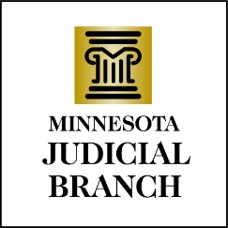

Judicial Council Agenda
November 16, 2023
9:00 a.m.
Room 230, MN Judicial Center and via Zoom

- Approval of Draft September 14, 2023, Meeting Minutes

- Governance Follow Up

- Discussion Item: Proposed Revisions to Judicial Council Policy 523: Storage of Captured Records of Court Proceedings and Judicial Council Policy 523.1: Capturing the Record of Court Proceedings-Back Up of Recordings and Redundant Storage

- Discussion Item: Sixth District Audit Follow Up

- Discussion Item: Treatment Court Audit Follow Up

- Discussion Item: Treatment Court Cannabis Workgroup Budget Proposal

- Decision Item: New Treatment Court Approval

- Discussion Item: LAW Recommendations

- Decision Item: Approval of the 2024 Payables List

- Other Business

- Adjourn

