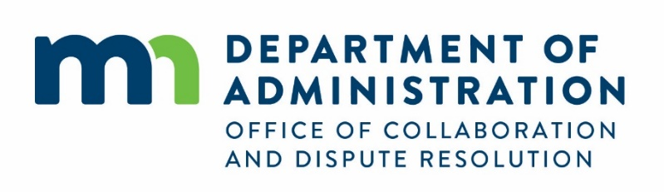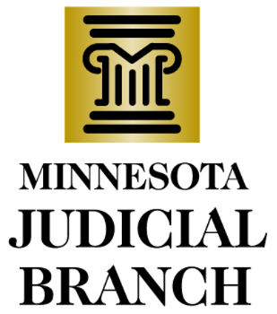

Community Dispute Resolution Grant Program Narrative Progress Report
[Template last updated: 2/1/23]

Reporting organization
Reporting organization:

Name and Email of Contact Person: | Report Period:

Report dates
Narrative reports are due twice per grant year / four times per biennium.

Grant year | Fiscal Year 1 | Fiscal Year 2
Reporting period | July 1-Dec. 31 | Jan. 1-June 30
Report due | Feb. 1 | Feb. 1

Report recipients
Completed reports should be emailed to both the State Courts Grant Program Manager and the OCDR Grants Program Manager any time before the report due date.

Bridget Gernander
State Courts Grant Program Manager
bridget.gernander@courts.state.mn.us

Jessica Shryack
OCDR Grants Program Manager
jessica.shryack1@state.mn.us

Report questions
Please provide a narrative description of the following questions:

- If applicable, how have you incorporated Grant Review Committee feedback provided in your most recent grant award letter? (500 words)

- Provide 2-3 examples highlighting the impact of your work during the report period. (500 words)

- List any significant problem areas that developed and how they were or will be resolved. (500 words)

- What are your organization’s planned activities for the next report period of the grant? (500 words)

