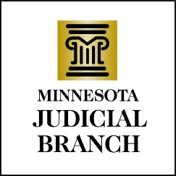

Judicial Council Agenda
April 18, 2024
9:00 a.m.
Room 230, MN Judicial Center and via Zoom

- Decision Item: Approval of Draft March 14, 2024, Meeting Minutes

- Discussion Item: Performance Measures Report and Backlog Update

- Discussion Item: Development of the FY26/27 Judicial Branch Budget Request

- Discussion Item: Treatment Court New Funding Policy

- Decision Item: Continuation of Temporary Referees

- Discussion Item: Strategic Planning Policy

- Discussion Item: Other Business
a. Legislative Update
b. Judicial Council Courthouse Visit
c. Recognize Departing Member

- Adjourn

