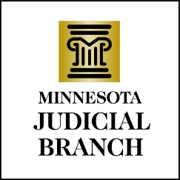

Judicial Council Agenda
May 16, 2024
9:00 a.m.
Room 230, MN Judicial Center and via Zoom

- Decision Item: Approval of Draft April 18, 2024, Meeting Minutes

- Discussion Item: Draft FY25 Operational Plan

- Decision Item: Strategic Plan Policy

- Discussion Item: Treatment Court Initiative Work Plan and Annual Report

- Discussion Item: Treatment Court Initiative Charter

- Decision Item: Treatment Court New Court Funding Policy

- Discussion Item: 3rd Quarter Financial Projection

- Discussion Item: FY26/27 Biennial Budget Request

- Discussion Item: Judicial Council Policy 205.2, New Judge Travel Reimbursement Policy

- Discussion Item: Regular meetings with the Association of Minnesota Counties, the County Attorneys Association, and the Public Defenders

- Other Business
a. Legislative Update
b. Judicial Council Courthouse Visits
c. District Implementation Committee Convener
d. Recognize Departing Member

- Adjourn

