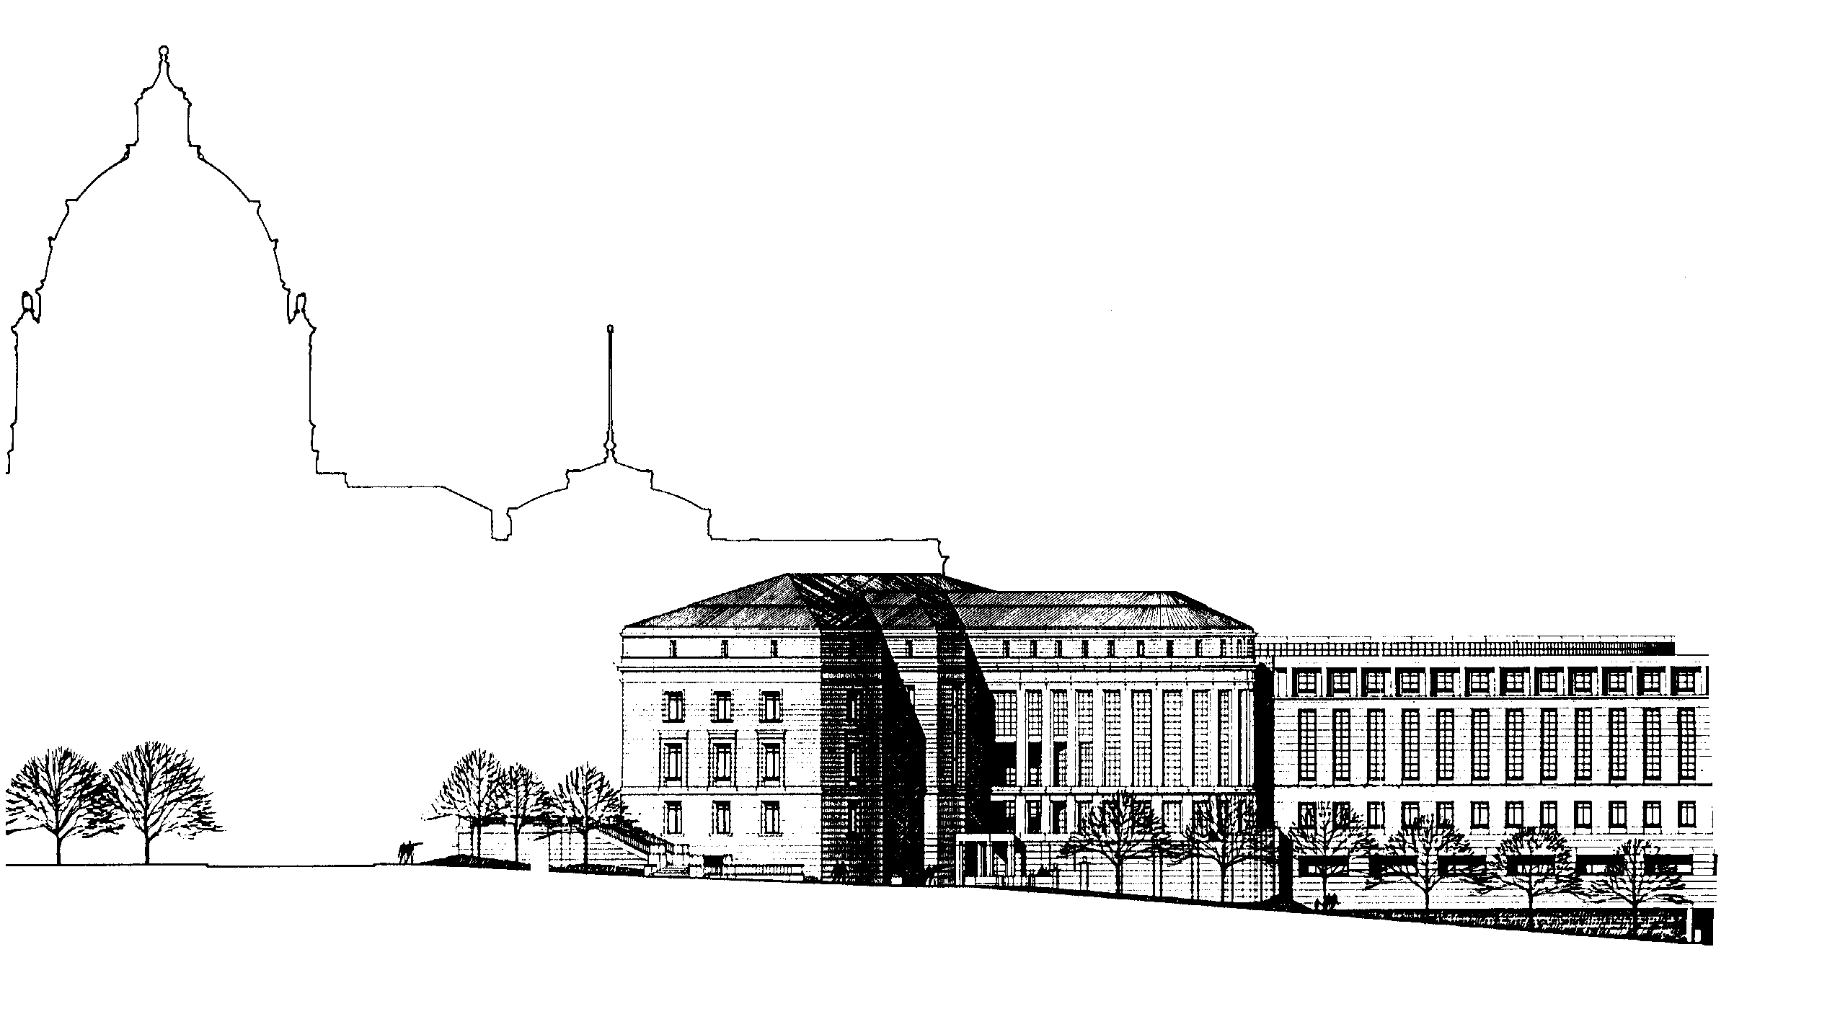
LEGAL SERVICES GRANT PROGRAMS STATE COURT ADMINISTRATOR’S OFFICE
25 Rev. Dr. Martin Luther King, Jr. Blvd.
Saint Paul, Minnesota 55155
www.mncourts.gov/lsac
651-284-4379

MEMORANDUM

TO: Potential LSAC Grant Applicants
FROM: Bridget Gernander, Executive Director
RE: FY22-23 Grant Application Guidelines
DATE: January 15, 2021
The Legal Services Advisory Committee (LSAC) intends to award grants for the two-year period from July 1, 2021 to June 30, 2023 (FY22-23).
Where Does the Money Come From?
Discretionary Grant Funds - LSAC will distribute approximately $4,500,000 per year in discretionary grant funds from three main sources:
- Funding appropriated by the Minnesota Legislature, governed by Minn. Stat. 480.242(b) for grants to legal services and alternative dispute resolution programs serving clients who meet the statutory poverty guidelines. More details about legislative funding eligibility are listed in the Statutory Interpretation and Financial Guidelines document at www.mncourts.gov/lsac. LSAC distributed $2,208,000 per year from the FY20-21 legislative funding available for discretionary grants (also known as the 15% funds). The committee will not know the total funding available for FY22-23 until the 2021 legislative session has ended.
- The civil legal services portion of Minnesota attorney registration fees can be spent at the discretion of LSAC for any purpose that supports civil legal services. LSAC distributed approximately $2,000,000 per year in attorney registration fee revenue in the last grant cycle. This funding is expected to remain flat.
- Interest on Lawyers Trust Account (IOLTA) revenue is used to enhance the availability of legal services for low-income Minnesotans and other vulnerable populations, to support programs of law related education and programs to enhance the administration of justice. LSAC plans to distribute approximately $500,000 per year from IOLTA funds and related revenue. This is 40% decrease from the prior grant cycle due to low interest rates.
Formulaic Grant Funds – LSAC will distribute the remaining 85% of the funding appropriated by the Minnesota legislature under Minn. Stat. 480.242(a). Only programs meeting the statutory criteria should submit a proposal under this section. LSAC will choose from among the eligible programs and distribute the funding using the poverty population by county formula described in the statute.

What Kind of Grants Will LSAC Make?
For the FY22-23 grant cycle, LSAC will consider proposals in four categories:
- General Operating Grants for Staff Legal Services. Regional grants that can be used for organizational expenses related to the provision or support of civil legal services by staff attorneys to economically disadvantaged Minnesotans. Regions are defined on the last page of this memo. LSAC is charged with ensuring access to a base level of civil legal services around the state. Regional proposals will be evaluated to work towards an equitable distribution of resources.
- General Operating Grants for PAI Services. Regional grants that can be used for organizational expenses related to private attorney involvement (PAI) services to economically disadvantaged Minnesotans. PAI is defined to include both pro bono and judicare. Regions are defined on the last page of this memo. LSAC is charged with ensuring access to a base level of civil legal services around the state. Regional proposals will be evaluated to ensure a more equitable distribution of resources.
- Project Grants. Grants for projects to enhance the availability of legal services or alternative dispute resolution for low-income Minnesotans and other vulnerable populations, to support programs of law related education and to enhance the administration of justice.
- 85% Legislative Funding Grants. These are the formulaic grant funds described above. Applicants must fit the criteria of Minn. Stat. 480.242(a).
Applicant organizations can submit proposals in more than one category.

How Will LSAC Score the Proposals?
Minnesota Judicial Branch Policy requires that all grant review be conducted using set review criteria. In this grant cycle, each proposal for grant funding will be evaluated and awarded up to 30 points (up to 15 organizational capacity points + up to 15 points for each proposal type) based on the following criteria:

A. Organizational Capacity Evaluation
Scoring Category | Description (with correlating application questions) | Points
Board Strength | A high scoring organization will demonstrate:  - diversity of Board membership (A3)  - clear training on good governance principles, such as what is described on the Minnesota Council of Nonprofits website (A4)  - active and engaged Board of Directors (A5) | Up to 5
Evaluation and Planning | A high scoring organization will demonstrate:  - evaluation processes in place to improve organizational programming, such as what is described on the National Council of Nonprofits website (A6)  - strong strategic planning process where the organization has both a long term plan and short term objectives for accountability (A7)  - clear succession planning in place for Executive Director position (A8) | Up to 5
Financial Strength | A high scoring organization will demonstrate:  - ability to anticipate challenges and demonstrated capacity to adapt (A9)  - a realistic and clear budget that is part of an overall program plan (A10) | Up to 5
Total Possible Points = 15

B. General Operating Grant for Staff Services Evaluation
Scoring Category | Description (with correlating application questions) | Points
Community Impact | A high scoring proposal will demonstrate:  - clearly defined community to be served, either geographically or for specific populations (B1)  - evaluation and identification of solutions to address current and emerging client need (B4) | Up to 5
Delivery System Impact | A high scoring proposal will demonstrate:  - how the proposal contributes to a delivery system where there is a base level of access to direct legal representation services and other eligible services in all Minnesota counties (B5)  - how legal needs are assessed and prioritized to deliver a full range of services in the region (B2 and B3) | Up to 5
Collaboration | A high scoring proposal will:  - recognize other service providers in the region and address how this project will collaborate with other providers to reduce duplication and/or to enhance client service (B6)  - as well as coordinate with law library or court self-help services when applicable or other innovative partners (B7) | Up to 5
Total Possible Points = 15

C. General Operating Grant for PAI Services Evaluation
Scoring Category | Description (with correlating application questions) | Points
Community Impact | A high scoring proposal will describe:  - clearly defined community to be served by private attorneys, either geographically or for specific populations (C1)  - evaluation and identification of solutions to address current and emerging client need (C4) | Up to 5
Delivery System Impact | A high scoring proposal will clearly demonstrate:  - how the proposal contributes to a delivery system where there is a base level of access to civil legal services in all Minnesota counties (C5)  - address both pro bono and judicare models and how they could be used in the region to achieve a full range of PAI services, including advice, brief service and extended representation and Other Eligible Services (C2 and C3) | Up to 5
Collaboration | A high scoring proposal will:  - recognize other service providers in the region and address how this project will collaborate with other providers to reduce duplication and/or improve client services (C6)  - as well as coordinate with law library or court self-help services when applicable or other innovative partners (C7) | Up to 5
Total Possible Points = 15

D. Project Grant Evaluation
Scoring Category | Description (with correlating application questions) | Points
Community Impact | A high scoring proposal will:  - have a broad geographic reach and/or provide support services or education to a wide range of programs or client groups (D2) | Up to 5
Delivery System Impact | A high scoring proposal will:  - describe how this project uses technology or other approaches to support an integrated service delivery infrastructure (D3) | Up to 5
Collaboration | A high scoring proposal will:  - provide effective and efficient use of LSAC funds (D4)  - demonstrate that the project is collaborative and not duplicative of existing services (D5) | Up to 5
Total Possible Points = 15

E. 85% Legislative Funding Evaluation
Scoring Category | Description (with correlating application questions) | Points
Community Impact | A high scoring proposal will:  - demonstrate the work of the Organization to effectively serve clients through comprehensive needs assessment (E4)  - demonstrate the work of the Organization to effectively use resources to meet their mission through strategic planning (E5) | Up to 5
Delivery System Impact | A high scoring proposal will:  - ensure coverage of basic civil legal services throughout the counties or tribal lands to be funded through the statutory formula. (E2) | Up to 5
Collaboration | A high scoring proposal will:  - demonstrate efforts to prevent duplication in the counties or tribal lands to be funded through the statutory formula. (E3) | Up to 5
Total Possible Points = 15

What Is the Schedule for the LSAC Grants?
LSAC applications for FY22-23 funding must be received through the online grant management system by 4:30 p.m. on March 19, 2021. All grant materials are available at www.mncourts.gov/lsac.
There will be a workshop on February 9, 2021 from 1:00 – 2:30 p.m. via Zoom for any prospective applicants who would like to ask questions about the grant application or data submission. Organizations applying to LSAC for the first time are strongly encouraged to participate in the workshop. Email bridget.gernander@courts.state.mn.us for a link to attend the meeting.
All applications received by the deadline will be screened for compliance with LSAC’s funding criteria. Applicants who meet the funding criteria will be scheduled for a 45-minute interview with an LSAC panel to discuss the application and respond to any committee member questions. Applicants who do not meet the funding criteria will be notified that their application has been denied and for what reason. LSAC contemplates making grant awards before June 30, 2021, but funding decisions are dependent on when the legislature finalizes the allocation amount.

Summary of LSAC Grant Timeline for FY22-23
Application Materials Available | January 15, 2021
Informational Workshop | February 9, 2021 from 1:00 – 3:00
Applications Due | March 19, 2021 by 4:30 p.m.
Interviews | By appointment in April and May 2021
Grants Awards Finalized | Mid-June 2021 (meeting date TBD)

Please direct inquiries regarding grant applications to Bridget Gernander, Legal Services Grant Manager, at bridget.gernander@courts.state.mn.us or 651-284-4379.

What Should I Know Before Applying for an LSAC Grant?
LSAC reserves the right to reject any or all applications received that do not, in its opinion, serve the best interest of the Minnesota Supreme Court or the intent of this funding. The application is made for informational or planning purposes only. Neither the Supreme Court nor LSAC will be liable for any expenses incurred by any prospective grantee prior to the issuance of the grant. Upon submission, all applications become the property of the Supreme Court, which has the right to use any or all ideas presented in any application submitted, whether or not the application is accepted. All application materials are public data and may be made available to other interested organizations and individuals.
The selected grantee must understand and agree to the following conditions that shall be included as part of the final grant award agreement. A copy of the full grant award agreement is available on request.
- Inspection and Audit. The office and representatives of the Supreme Court, and the Minnesota Legislative auditor, or any of their duly authorized representatives, shall have access for purposes of audit and examination to any books, documents, papers, and records of the grantee.
- Certification of Non-profit Status. The grantee must certify that it is a 501(c)(3) non-profit corporation that it is governed by a board of directors composed of attorneys-at-law and consumers of legal services, including at least one client eligible member as defined in the Statutory Interpretation and Financial Guidelines document, available on the website at www.mncourts.gov/lsac.
- Supplemental Data Requests. In accepting a grant from LSAC, grantees will be asked to comply with all reasonable requests for supplemental data.
- Reduction in Grant Funding. In the event the Legislature reduces the appropriation for civil legal services or anticipated funding from other sources drops below the allocated level, LSAC may reconsider and reduce awards to grantees for the second year of the biennium.

Definitions Used Throughout LSAC Application
This section describes the terms that have specific meanings in the LSAC application materials. Please read through before starting the online grant application.
Comprehensive Needs Assessment. A comprehensive needs assessment is a process where a legal representation program surveys eligible clients, staff and community about what services should be the highest priority. A comprehensive needs assessment will help determine the allocation of scarce resources and staffing, incorporate information from a variety of stakeholders, including applicants and clients, and engage with the community to get feedback on how efficient, visible, and accessible the organization is, and generate data and information that the organization can use in its media effort to increase the visibility of legal aid, develop support for legal aid work, and encourage resource development
Legal Representation. Refers to those services through which lawyers and other legal advocates provide legal representation to clients, in an attorney/client relationship, whether using a staff, volunteer, judicare, or some other model.
Organization. Refers to your corporate entity, including all Programs as defined below and other parts of your entity, if any.
Other Eligible Services. Refers to law-related services (other than Legal Representation) eligible for LSAC funding. Examples include community legal education; advocacy on issues affecting eligible clients at the legislature or before other elected bodies, in administrative rulemaking, or the like; support to Programs that provide Legal Representation; mediation and/or other dispute resolution services, administration of justice; and other eligible law-related services not defined as Legal Representation.
Private Attorney Involvement (PAI). Refers to legal services provided by private attorneys, rather than staff attorneys, and includes both pro bono and judicare.
Program. Refers to that part of your Organization that provides law-related services, including but not limited to, services eligible for LSAC funding. Program services may include Legal Representation and/or Other Eligible Services.
Proposal. Refers to LSAC’s Request for Proposals across different areas: general operating grant for staff services, general operating grant for private attorney involvement (PAI) services, and project grants. Organizations can submit Proposals in more than one category.

Regions. LSAC follows the regional boundaries used by in the Minnesota legal services delivery system. Here is a detailed breakdown by county name and map.
- Northwest Region: Becker, Beltrami, Clay, Clearwater, Douglas, Grant, Hubbard, Kittson, Lake of the Woods, Mahnomen, Marshall, Norman, Otter Tail, Pennington, Polk, Pope, Stevens, Red Lake, Roseau, Traverse, Wadena, Wilkin plus any tribal land within the geographic boundaries of this region.
- Northeast Region: Aitkin, Carlton, Cass, Cook, Crow Wing, Itasca, Kanabec, Koochiching, Lake, Pine, St. Louis plus any tribal land within the geographic boundaries of this region.
- Central Region: Anoka, Benton, Big Stone, Chippewa, Chisago, Hennepin, Isanti, Kandiyohi, Lac qui Parle, Lincoln, Lyon, Meeker, Mille Lacs, Morrison, Renville, Sherburne, Stearns, Swift, Todd, Wright, Yellow Medicine plus any tribal land within the geographic boundaries of this region.
- Southern Region: Blue Earth, Brown, Carver, Cottonwood, Dakota, Dodge, Faribault, Fillmore, Freeborn, Goodhue, Houston, Jackson, Le Sueur, Martin, McLeod, Mower, Murray, Nicollet, Nobles, Olmsted, Pipestone, Ramsey, Redwood, Rice, Rock, Scott, Sibley, Steele, Wabasha, Waseca, Washington, Watonwan, Winona plus any tribal land within the geographic boundaries of this region.
