
George A. Lock
Court Administrator
Stearns County Courthouse
725 Courthouse Square.
St Cloud MN 56303

(320) 656 3625
Fax: (320) 656 3626
Stearns County
Seventh Judicial District
State of Minnesota

Pursuant to 7th Judicial District Administrative Policy 4.6 and by order of the Stearns County Bench,

IT IS Hereby ORDERED that:

- Persons granted entry into either the Historic Courthouse or the Courts Facility building (“court premises”) are permitted to possess electronic devices such as smartphones and cellular or mobile devices, computers and other electronic and web-enabled equipment while inside said buildings subject to the provisions set forth in this order.
- Electronic devices may be used in the common areas of court premises, such as lobbies and court administration office areas, but the power to all electronic devices must be turned off upon entry to a courtroom save as identified in paragraph (3) below.
- Licensed attorneys, licensed law enforcement personnel, self-represented litigants, guardians ad litem, corrections officers, interpreters and other persons authorized by the presiding judge may have in the courtroom cell phones, electronic tablets and lap top computers powered ON and in SILENT mode for the purpose of obtaining necessary information to conduct business with the courts. Voice communication and recording of pictures, video or audio shall not be made or displayed in the courtroom by any person unless specifically and expressly approved by the presiding judge.
- Law enforcement and court personnel are authorized to search persons and inspect electronic devices in any court facility to ensure compliance with this policy. An electronic device that is possessed or used in a manner that is not in compliance with this policy may be immediately seized. Any person violating this policy may be subject to a contempt of court order and the imposition of appropriate sanctions.
- A copy of this policy shall be posted at appropriate public locations at each court facility as determined by the court administrator and facility manager.

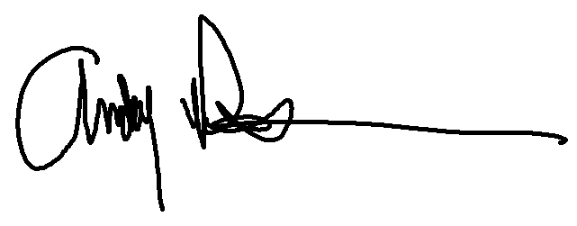
So ordered this 25th day of September 2023

Andrew R. Pearson
Stearns County District Judge

